Module 7: Interviewing Adult Sexual Abuse Victims

Time: 11:00 a.m. – 12:15 a.m., 1:15 p.m. – 2:15 p.m. (2 hours and 15 minutes)

Training Objectives:
- Identify techniques for interviewing during investigations of sexual abuse in confinement settings.

Materials Needed:
1. Easel pad and markers
2. PowerPoint® player/machine (laptop computer and LCD projector)
3. Screen or monitor
4. Video Clips: National Institute of Corrections Preventing Staff/Offender Over-Familiarity Scenarios

Training Tips:
- This module is designed to address the requirement in PREA standard 115.34 for investigators to be trained in techniques for interviewing victims of sexual abuse.
- This module is designed to be skill-based and to allow time for participant exercises. If there is time, this module should be extended to allow additional interview practicing exercises throughout the module. However, participants should be encouraged to be purposeful in improving their techniques outside of training as well. For example, suggest that participants tape themselves interviewing and ask an experienced colleague to critique it.
- The instructors should walk around the room during all activities in order to observe and give constructive comments during the debrief of the activities.
This module is best presented or co-presented by someone with extensive experience in interviewing and, preferably, someone experienced in interviewing victims, witnesses, and suspects in the context of sexual abuse or sexual harassment cases.
- Be advised that this module may contain material that utilizes concepts and language that may be upsetting or difficult for some participants. This may include statements

referring to genitalia, sexual harassment, sexual abuse, trauma, and suicide. Videos used may also contain profanity. Please review all materials prior to using to ensure they are appropriate for use in your agency and make substitutions where needed. You should also consider providing a general notice to participants at the beginning of each training session.
- Please note that this module was developed specifically for facilities that use the Adult Prisons and Jail or Juvenile PREA Standards. Facilities using the Community Confinement or Lockup standards should review all standard references to ensure that the content and language is appropriate for their facility type and inmate/resident population and adjust the material as needed to their specific circumstance.

Time | Lecture Notes | Teaching Tips
- | Interviewing Adult Sexual Abuse Victims | 
1 min | Objectives  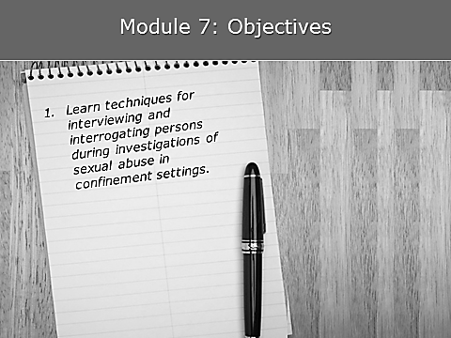  The objective for this module is to go over the best practice techniques for interviewing and interrogating people during investigations of sexual abuse in confinement settings. | Objectives
3 min | Sound Foundation  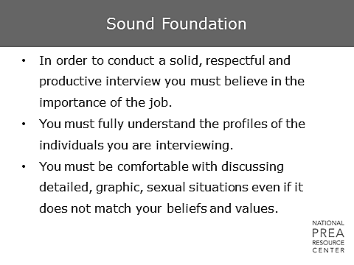  Interviewing is one of the most important skills for an investigator to master, and much of the development of that skill depends on experience in the field and individual practice. However, there are certain foundational pieces of information regarding interviewing victims of sexual abuse that all investigators should fundamentally understand.  - First, as with any investigation, you need to believe in the importance of your job. Interviewing victims of sexual abuse is difficult. It can be unpleasant and sometimes re-traumatizing for both the interviewer and the interviewee. It can take multiple sessions, and often the victim is unable to give the investigator the information needed to substantiate an allegation. Despite this, an investigator needs to remain convinced that their role in the response process to an allegation of sexual abuse or harassment is so important that the efforts they put into an interview are worth it, regardless of the chances of substantiation. As soon as an investigator becomes disillusioned and starts feeling his or her efforts are wasted, the interviews become less effective.  - We’ve discussed the dynamics of sexual abuse and sexual harassment in confinement, and the pathways taken by offenders to reach the criminal justice system. We’ve also discussed the issue of trauma and its impact on victims. Keep these issues in mind as you go into interviews.  - Most importantly, you must be comfortable conducting the interview and, in this case, that means discussing detailed, graphic incidents of sexual abuse and harassment. You must be comfortable with the terminology, and you must be comfortable asking the questions necessary to fully understand every detail of the alleged incident. | Sound Foundation
1 min | A Question of the Audience: Private Encounter  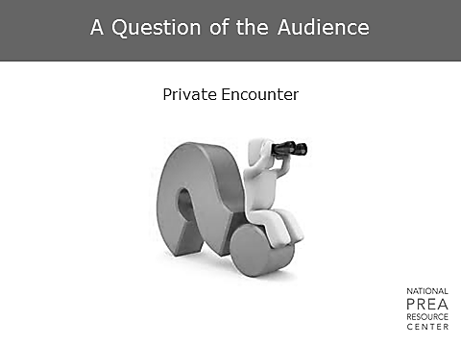  You are in a group of peers and friends. Is there anyone that would like to join me up front to discuss the most recent consensual, intimate relation they have had in the past week? | A Question of the Audience  Expect the audience to be confused and then awkward - giggling and squirming. Quickly follow up and state that the point of that question was not actually to have someone share a sexual encounter, but to make a point. If the group is uncomfortable discussing our consensual intimate relations, how can we expect sexual abuse victims to feel comfortable describing an extremely intimate event to us, a stranger who they have no reason to trust? Additionally, we’re not asking them to share a fond memory. We’re asking them to share an experience that was both humiliating and terrifying.
10 min | What do you think about sex?  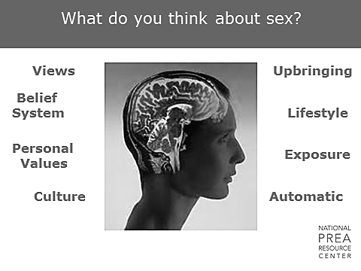  Everyone has a belief system and biases. These were developed over the course of your life, and are shaped by your upbringing, personal values, culture, lifestyle, and exposure to alternate lifestyles. As an investigator, your personal experiences and the emotional challenges you face during your investigations will impact how you approach your interviews with both alleged victims and suspects. Your attitudes, background, and biases are not a problem, but you need to be aware of them and manage them to successfully interview victims of sexual abuse.  Activity: Values and Judgments: We all bring our own values, judgments, and life experiences with us into work.  - How do we acknowledge those values and recognize when they influence us in our jobs?  - Do you believe people cannot get raped if they don’t want to be?  - What are your attitudes towards LGBTI and gender non-conforming inmates?  - How might past personal experiences or familiar experiences impact attitudes?  In a small group at your table, discuss how an investigator’s values may affect his/her interviews in a sexual abuse case. | What do you think about sex?    Break participants into a small group at their tables.
1 min | Interview  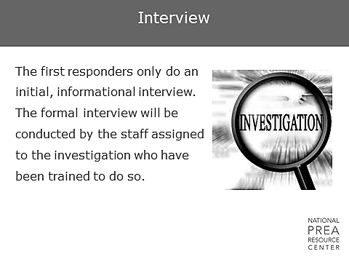  As we discussed in the last module, the first responders should only do an initial, informational interview. The investigator, who has received training per PREA standard 115.(3)34, should conduct the formal interview. | Interview
1 min | What is a Victim Interview?  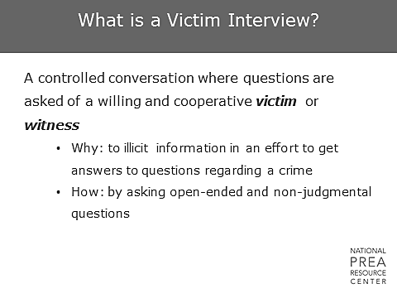  The important point here is that these interviews are with willing and cooperative victims or witnesses. They are open-ended and non-judgmental. You do not want yes or no answers. Use questions like “Tell me about…” or “What did you hear?” or “What did you see?” You do not want to ask questions like, “Were you raped?” | What is a Victim Interview?
10 min | Activity    We’ll be doing a number of these exercises throughout the module. Remember, though, that the best way to improve your interviewing skills is to listen to your own interviewing tapes and practice. Asking your co-workers to critique those tapes can be equally helpful. | Activity: Interviewing. Break the class into groups of three. Have them spread out around the room. Ask them to select a victim, an investigator, and an observer. Choose one of the videos you’ve seen so far (in either the First Response Module or in this module) and use that as your scenario. Have the investigator interview the victim for 5 minutes and then receive feedback for 5 minutes.
2 min | Preparation  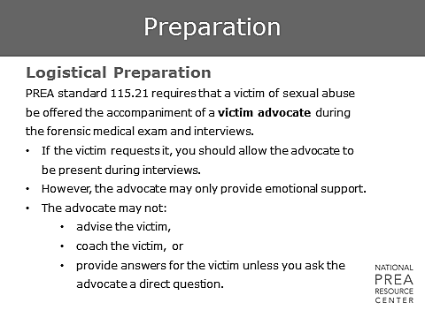  The victim advocate is there solely for the mental health and well-being of the victim. They are not there to participate in the interview, influence the investigator to ask questions differently or ask different questions, to interject comments, etc. (An exception may be a circumstance where clinical expertise may be of assistance to the investigator in better understanding the victim, resulting in a more effective interview.)  - Be aware that a victim advocate must be made available to the victim if they request that service at any point in the process, so make use of them!  - They can help you with victims who may be concerned because they don’t know the investigations or prosecution process. They may be able to take some of the burden off your mental health practitioners.  - Ultimately, they may be able to help you create a more comfortable environment for your victim. This will make the victim more comfortable with you and more likely to cooperate with the investigation process. | Preparation  Insert agency processes for involving victim advocates in response processes.
2 min | Vulnerable Victims May Be:  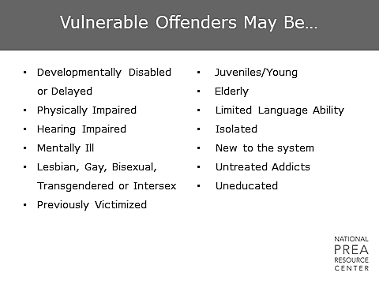  You’ll be interviewing victims of all types, but be aware that you need to be prepared to interview individuals who may be vulnerable due to certain characteristics as identified by the Bureau of Justice Statistics through their national inmate/youth surveys and by practitioners in the field. Throughout the rest of this module, we will be discussing interviewing techniques generally and specifically with regards to gender considerations, developmental considerations, and mental illness considerations.  Although we will be discussing basic techniques that should be considered with these populations, always remember that each case is different, and each offender is unique. Just as it is important to recognize the impact that both victim/suspect and interviewer characteristics can have on what techniques may be most effective in the interview, it is important to recognize the danger of stereotyping. | Vulnerable Victims May Be  Ask: How could the characteristics on the slide impact your interviewing techniques?
10 min | Interviewing | Activity: Interviewing  Break the class into the same groups of three people, and spread out around the room. Rotate the roles and have the trainees choose one of the two videos you’ve seen so far and use that as your scenario. Have the investigator interview the victim for 5 minutes and then receive feedback for 5 minutes.
2 min | Interviewing Tips  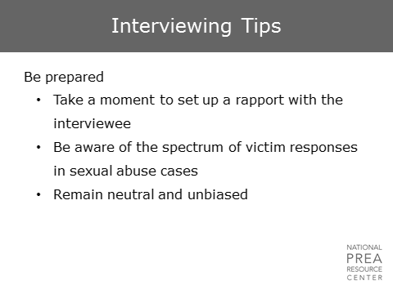  Take a moment to build a rapport with the interviewee. Ask them:  - How long they’ve been in the facility, and how they got there.  - How their living situation has been – are they double bunked or single celled?  - Are they in an education program?  - Are they working?  You need them to become comfortable with you.  So, what happens if you’ve already had interactions with this victim that have not been positive? What if the last time this individual saw you was when they were in your office, and you were giving them extended segregation time? You need to find ways to change your role and make them comfortable with you. | Interviewing Tips
3 min | Interviewing Tips  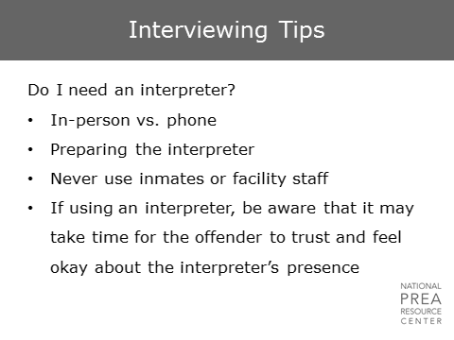  Establish in advance if the inmate speaks English as a second language and, if so, what their fluency level is and what their first language is.  - Do you speak that language?  - If you’re working with other law enforcement, do they speak that language?  - If not, find an interpreter who is fluent in the appropriate language.  If you have the choice between using an in-person interpreter and a call service, having someone come in is more personal and may make the victim more comfortable. However  - Make sure you prepare the interpreter in advance of the interview so you know that they are comfortable discussing incidents of sexual abuse in detail. If they don’t know what to expect in the interview, they may express shock, pity, or disgust in a way that is detrimental to the interview.  - Give the victim time to get comfortable with the presence of the interpreter before jumping into more difficult questions.  Never use another inmate as an interpreter – you don’t know their relationship to the victim, and you may not be able to trust the translation. Additionally, the victim is unlikely to share information with you when someone from the general population is in the room. This is true for facility staff as well – using someone from outside the facility is generally better practice. | Interviewing Tips  Insert demographic information specific to your agency regarding languages spoken by inmates.  Insert agency-specific information regarding accessing interpreters – language lines, calling in interpreters, etc.
2 min | Interviewing Tips  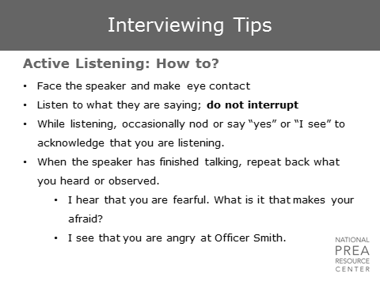  The best way to convey to a victim that you care about their case and what they are saying is to actively listen to them.  - Make eye contact  - Don’t interrupt  - Nod from time to time  - Remain neutral  - Paraphrase what they are saying.  Ask for clarification if you don’t understand.  - Victims and witnesses will use slang to describe body parts and genitalia. If someone uses a term that you are not familiar with, ask them what it is. Don’t assume you know what they’re talking about.  - Don’t be afraid to use anatomically correct drawings if necessary and to ask the offender to point to the area that they’re talking about. Use the terms the victim knows. | Interviewing Tips
2 min | Interviewing Tips  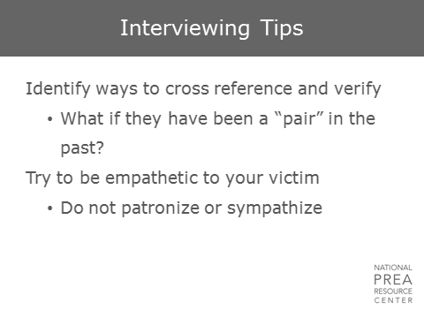  During the interview, identify ways to cross reference and verify what the victim is telling you. Think about what is available to you.  - Review video tapes, phone calls, money exchanges.  - Talk to staff who work on the victim’s cell block and offenders who live on the cell block.  - If the offender is involved in education, programs, work opportunities, etc. talk to those staff members.  You want to talk to people to see if they have noticed if the victim’s demeanor has changed recently, and if that coincides with the timeframe they have given you for the abuse.  - Be empathetic, but don’t patronize.  - Don’t promise that you’ll keep him or her safe or say that you understand.  - Focus on listening rather than consoling. | Interviewing Tips
2 min | Interviewing Techniques  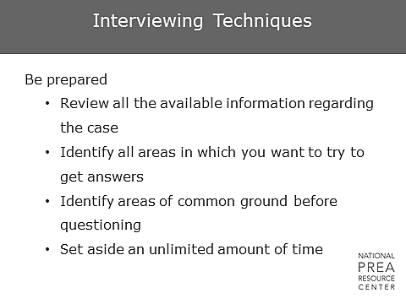  You have a great resource that most law enforcement do not have access to: your victim’s histories – health, educational, and disciplinary. Take time to review those. Have you read their file, their psych history, family history? There may be additional information available if the victim is female.  Make sure you have enough time for the interview.  - We have discussed over the course of this training that victim interviews should be sequenced; if a victim has to provide a detailed narrative of the abuse to multiple people, he/she can be re-traumatized and stop cooperating with the investigation. Therefore, an investigator should communicate and collaborate with the other people who have contact with the victim to ensure all interviews are purposeful.  - Additionally, it is important for investigators to recognize that multiple interviews over time can be exhausting and stressful for victims even when they are not repetitive. Although some cases will require multiple interviews, investigators should make every effort to minimize the number of interviews required when possible, which means making sure you schedule enough time for the interviews you conduct. Ending an interview prematurely because of a prior commitment will damage your rapport, as will looking at your watch throughout the interview. Don’t try to rush the victim. We are all busy; don’t make the victim responsible for your schedule.  This is especially true with women, as they tend to provide more information, which takes more time. Additionally, allow time for him/her to ask questions.  - “What will happen to Officer Sampson if I talk to you?”  - “What will happen to Susan since she had it happen to her but never reported the gifts?” | Interviewing Tips
2 min | Interviewing Techniques  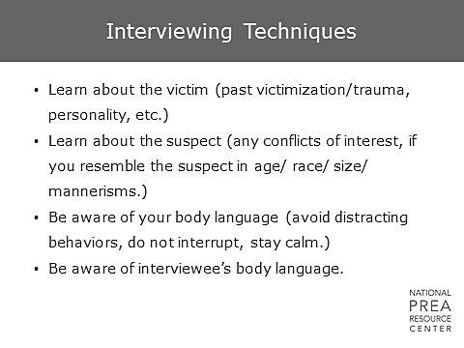  Through your mental health staff, you may have the opportunity to learn about past trauma. Use your mental health staff. They can be a great resource of information and, for victims with severe mental health issues, they can join the interview to facilitate.  Additionally, learn about the suspect.  - Learn about their history  - Learn about their appearance and if they have any particular mannerisms.  As we discussed in the module on trauma, you could trigger your victim simply by looking like the perpetrator. Pay attention to this in advance of the interview. Additionally, be aware of your body language and the victim’s body language.  - Are you relaxed and non-threatening, or are you tense, with an aggressive stance?  - Are you yawning a lot?  - Are you at eye level with the victim, or are you looking down at them?  What about the victim’s body language? Are they comfortable? Does their body language shift depending on your actions? | Interviewing Tips
5 min | Video  Frank was arrested for public drunkenness and disorderly conduct. It was the first and only time he was arrested. If we think these sorts of events don’t take place in our correctional facilities, we’re wrong. |   Just Detention International provides training clips on youtube. Consider using the following clip of Frank Mendoza discussing his experiences:  http://www.youtube.com/watch?v=BN7OIjMztgo
10 min | Interviewing  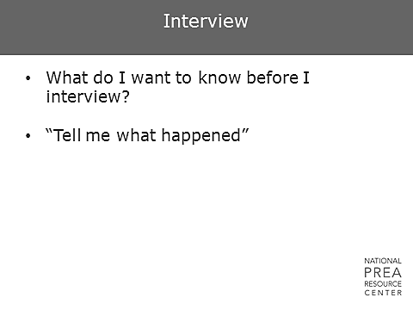 | Activity: Interviewing  Break the class into the same groups of three. Have them spread out around the room. Rotate the roles so everyone has been in every role. Use this video as your scenario, and interview Mr. Mendoza for 5 minutes and then receive feedback for 5 minutes.
2 min | Interviewing Techniques  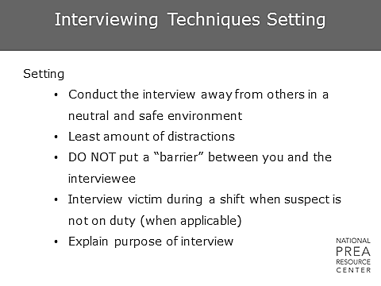  In the module on trauma, we discussed the importance of location in interviews and having a private, quiet place to conduct the interview.  - Try to minimize distractions – what can you hear from your interview room? What can you see?  - Don’t separate yourself from the interviewee with any sort of barrier, such as a table or desk. Create an atmosphere that is more conversational than interrogatory.  - As we mentioned previously, if the suspect is a staff member, conduct the interview when the staff member is not on duty. Retaliation is a fear and a reality for victims.  - Explain the purpose of the interview, but don’t let that lead to asking yes/no or multiple choice questions.
2 min | Interviewing Techniques  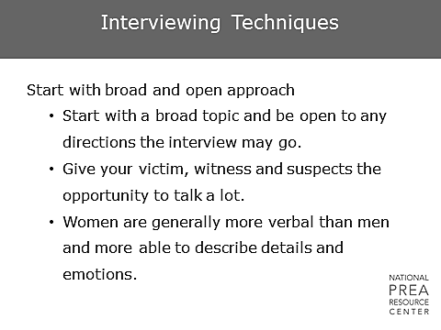  Start with broad topics and be open to any direction the interview may go.  - Have a list of questions you want to ask, but don’t feel the need to rigidly stick to the list.  - Give your victim, witness, and suspects the opportunity to talk. You may gain more information by letting them lead you.  - Women, in particular, may be more verbal and may go into more detail or spend more time discussing their emotions. Do not be afraid to bring the conversation back on topic if needed. | Interviewing Techniques
1 min | Interview Techniques  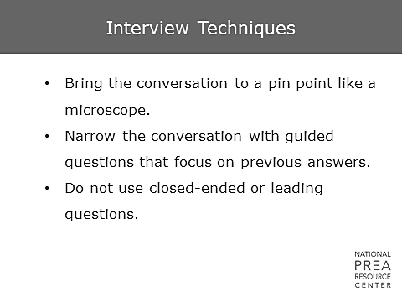  Over time, narrow the conversation with guided questions that focus on previous answers. As always, do not use closed-ended or leading questions. | Interviewing Techniques
10 min | Interviewing | Activity: Interviewing  Break the class into new groups of three. Have them spread out around the room. Assign one person the role of victim, one the role of investigator, and one the role of critiquing. Interview the female victim of staff sexual misconduct portrayed in the video watched in the First Response and Evidence Collection module (see slide 23) with the goal of getting the victim to feel comfortable and tell you what happened. Then spend 5 minutes giving feedback.  Have trainees take notes since they will need them for the last role play activity.
4 min | Video   |     Show the video of a victim interview at this link: https://www.youtube.com/watch?v=p196J_c31dA&t=3s  Note that even though this interview does not occur within the correctional setting, many of the assumptions and biases the investigators show are universal and can still be useful for training.  If there is time, ask participants to identify problems with how this interview is conducted, referring back to what they have learned so far.  This video can also be a good segue into the next section on gender and communication.
2 min | Gender and Communication  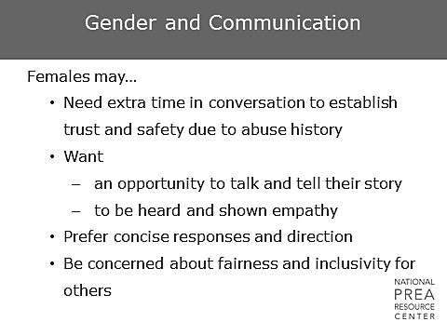  The next few slides address gender and communication and areas that investigators may want to consider when interviewing men vs. women. However, it is important to reiterate that each offender is different, and the techniques we are going to discuss may not be appropriate in every case. Use your best judgment.  With women, you may need extra time to build rapport and build trust.  - Women may want and require more direction in the questions you ask, and may be concerned about the impact the interview will have on their friends or the aggressor.  - Be aware of the advantages of having a male vs. a female interviewer. Don’t be afraid to bring someone else in to conduct the interview if it seems necessary. Some women, especially those who will be discussing sexual acts, may feel more comfortable with a female interviewer. | Gender and Communication
1 min | Gender and Communication  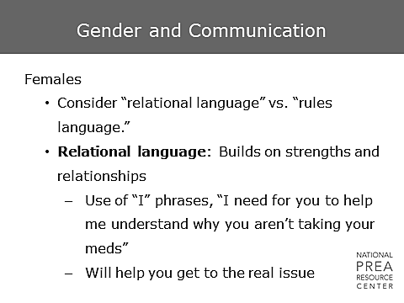  When interviewing women, try to avoid being authoritative.  - Women may respond better to relational language. Ask them to help you by doing something, or bring them into the decision making process.  - Rules language, such as “take your meds, or you’re going to segregation” may elicit resistance, anger, and defensiveness from women.  - Use an approach that will enhance cooperation. | Gender and Communication  Ask: What have you seen with the women you work with?
2 min | Gender and Communication  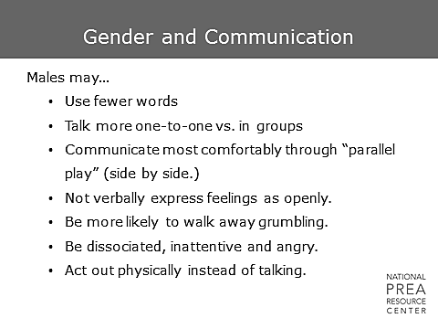  It may be more difficult for male offenders to express their feelings.  - Males may be boastful about their sexual experiences, regardless of whether the incident was abusive. Society often does not consider incidents of sexual activity between female staff and male inmates (or female teachers and male high school students) to be abusive, which makes it difficult for men to report it as such.  - There is a social pressure among males to be strong and aggressive rather than emotional, which is often viewed as a feminine trait.  - Unlike the more fluid personal and social boundaries of women, there is more pressure for men to maintain rigid boundaries. This may make it harder for men to express their feelings. But if you reach a point where they are able to express their feelings, they may need a substantial amount of time to work through it. | Gender and Communication
1 min | Interviewing: LGBTI Inmates  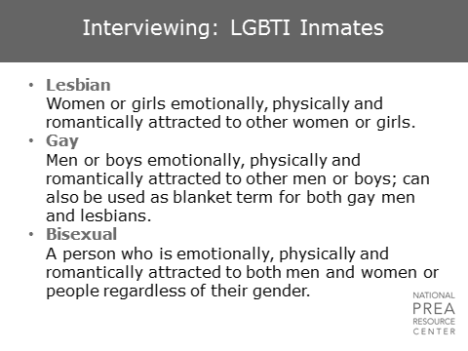  Expressions of non-heterosexual sexuality and gender nonconformity are becoming more socially acceptable, and this will impact what we see from offenders in our facilities. Being aware of the terminology is important. | Interviewing: LGBTI Inmates
5 min | Interviewing: LGBTI Inmates  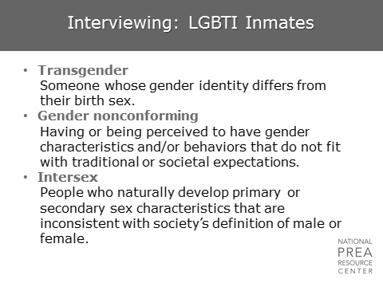  It’s important to understand the difference between gender and sex.  - Sex is biological.  - Gender is what is socially or culturally learned.  - If your biology includes female genitalia, there are social expectations for you to be feminine.  - If your biology includes male genitalia, there are social expectations for you to be masculine.  - Someone who is transgender is someone who has the genitalia of one sex, but who self-identifies with the gender of the other. So, someone who has female genitalia but who self-identifies as male.  - A person’s self-identification as transgender does not impact their sexual orientation. So, if you have someone with male genitalia in your facility who self-identifies as female, this does not mean that they are sexually attracted to men. They may be, but the two do not necessarily come together.  Transsexual is also a term that we hear from time to time. A transsexual person is someone who has had their genitalia surgically altered to match their self-identified gender. So, a transsexual person is typically transgender, but not all transgender people are transsexual. In fact, many transgender individuals do not feel the need to surgically alter their genitalia.  Gender non-conforming individuals are those who are not necessarily transgender (although they can be), but have characteristics or behaviors that are generally associated with the opposite sex. What is considered to be gender non-conforming evolves over time. For example, twenty years ago, pants were considered masculine clothing, and women who wore pants may have been considered to be gender non-conforming. This is no longer the case. If someone is extremely gender non-conforming, that person may be more vulnerable to sexual harassment or abuse.  Intersex individuals are people who are born with the biology of some combination of both male and female genitalia. This may be externally apparent or not – an intersex person could have both male and female genitalia. The condition can also be chromosomal, and not externally apparently. | Interviewing: LGBTI Inmates  Ask: What are stereotypically feminine traits?  Ask: What are stereotypically masculine traits?
1 min | Lesbian, Gay, Bisexual Inmates  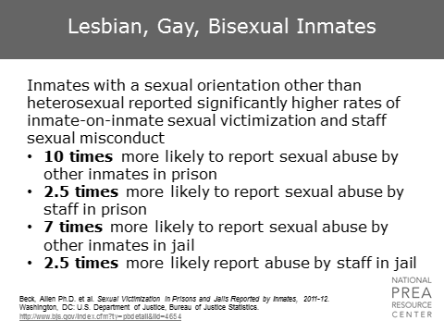  We’re talking about LGBTI inmates because this group of inmates reports much higher rates of sexual victimization than heterosexual, gender conforming offenders in the Bureau of Justice Statistics national surveys.  - In prison, lesbian, gay, and bisexual inmates are ten times more likely to report abuse by other inmates, and two and one-half times more likely to report abuse by staff.  - The numbers are similarly high in jails, where they are seven times more likely to report abuse by other inmates, and two and one-half times more likely to report abuse by staff. | Lesbian, Gay, Bisexual Inmates  This is an excellent opportunity to use agency-specific data, which will likely be more meaningful for agency staff.  The data that is provided is the most recently available national-level data.  Beck, Allen Ph.D. et al. Sexual Victimization in Prisons and Jails Reported by Inmates, 2011-12. Washington, DC: U.S. Department of Justice, Bureau of Justice Statistics.  Refer to “Sexual Victimization in Prisons and Jails Reported by Inmates, 2011-12” attachment
1 min | Transgender Inmates  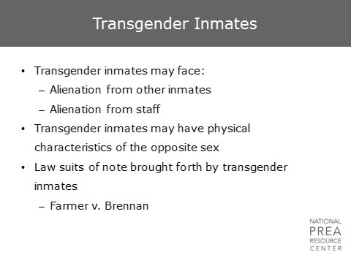  - Transgender inmates are particularly at risk as they may have physical characteristics of the opposite sex due to hormone therapy or smaller plastic surgeries.  - Transgender inmates have been involved in a number of prominent lawsuits against corrections agencies. In particular, Farmer v. Brennan, which was mentioned in the legal module, is one of the key lawsuits leading to PREA, in which a transgender inmate was repeatedly sexually abused in general population. | Transgender Inmates
1 min | Lesbian, Gay, Bisexual, Transgender and Intersex Inmates  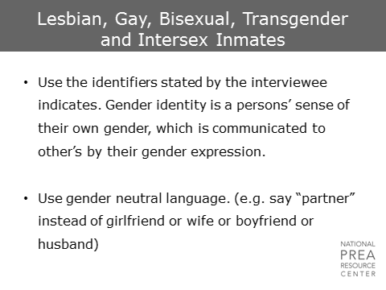  When interviewing LGBTI inmates, be respectful and use the identifiers requested by the interviewee.  - If, for example, you are interviewing someone who is or could be, transgender, ask them what pronoun you should use. Using their preferred pronoun will demonstrate respect on your part and increase their comfort.  - Refrain from expressing any biases during the interview, and don’t make assumptions based on sexual orientation or gender identity. A gay man in a same-sex relationship can still be raped, just as a heterosexual woman in a relationship can be raped.  - Use the term “partner” instead of girl/boyfriend or husband/wife to avoid putting the interviewee in a position where they have to correct you. | Lesbian, Gay, Bisexual, Transgender and Intersex Inmates
1 min | Profile: Developmentally Disabled  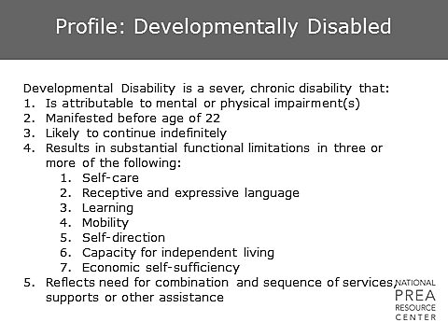  According to the Developmental Disabilities Act, section 102(8), "the term 'developmental disability' means a severe, chronic disability of an individual 5 years of age or older that:  - Is attributable to a mental or physical impairment or combination of mental and physical impairments;  - Is manifested before the individual attains age 22;  - Is likely to continue indefinitely;  - Results in substantial functional limitations in three or more of the following areas of major life activity;  - Self-care  - Receptive and expressive language;  - Learning;  - Mobility;  - Self-direction;  - Capacity for independent living; and  - Economic self-sufficiency.  - Reflects the individual's need for a combination and sequence of special, interdisciplinary, or generic services, supports, or other assistance that is of lifelong or extended duration and is individually planned and coordinated, except that such term, when applied to infants and young children means individuals from birth to age 5, inclusive, who have substantial developmental delay or specific congenital or acquired conditions with a high probability of resulting in developmental disabilities if services are not provided." | Profile: Developmentally Disabled
1 min | Profile: Developmentally Disabled  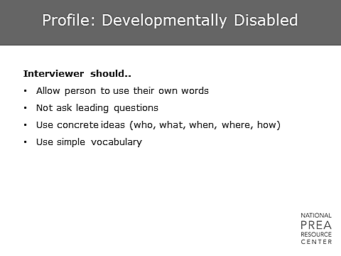  Developmentally disabled inmates can be difficult to interview.  - Inmates may want to please you and may tell you anything you want to hear. Don’t ask leading questions like “Did you see John rape Marty?” It’s important that you ask them open-ended questions to avoid putting words in their mouths.  - Developmentally disabled inmates may have memory gaps and a short attention span. They’ll also take the blame for things they didn’t do. Don’t go into these interviews with any preconceived notions, and make sure you hear the full story.  - Use simple words and consider the use of anatomically correct drawings or dolls to ensure accuracy of communication.  - Additionally, with all inmates, pay attention to their medication. Depending on what medication they are taking and when they take that medication during the day, there may be better times during the day to interview them. Talk to your mental health staff to determine what might be relevant. | Profile: Developmentally Disabled
1 min | Limited Language Ability  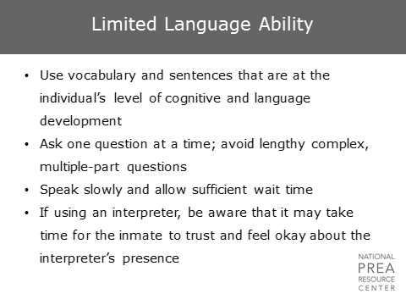  Ensure you speak at the level of the inmate you are interviewing.  - Use terminology that they understand. If you confuse them with complex words, they may withdraw or stop cooperating.  - Ask one question at a time – if you ask two or three questions at a time, they may lose track of what you’re asking.  - Speak slowly and clearly, and wait for your interviewee to answer even if it’s taking them a while. Don’t ask the question a second time unless you ask permission to do so – re-asking the question may be interpreted as a judgment on their intelligence and may cause offense. | Limited Language Ability
2 min | Mentally Ill  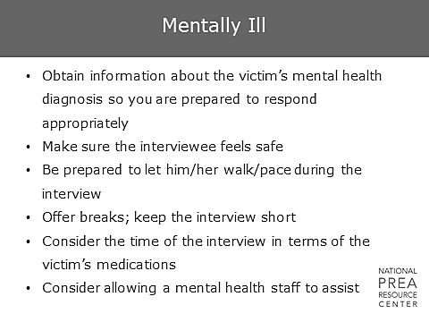  This section addresses interviewing techniques with severely mentally ill inmates. These considerations will not necessarily apply to any inmate who is on the mental health caseload. Inmates who are clinically depressed or on anti-depressants, for example, may not fall into this category.  - Make sure you have received the victim’s mental health diagnosis so you are prepared. Talk to your mental health staff to help formulate questions if they have a difficult diagnosis. They may have helpful recommendations that will be beneficial to your interview.  - Sometimes people with mental health issues need to move around a lot. Moving or pacing may help them think. This can be hard for investigators, but if you’re comfortable with the offender and it allows them to think more clearly, let them move around in the interview room.  - Be prepared to conduct multiple, short interviews with some offenders. Mentally ill inmates often cannot concentrate for extended periods, and breaking up an interview will allow them to stay focused when you are asking questions. | Mentally Ill
1 min | Mentally Ill  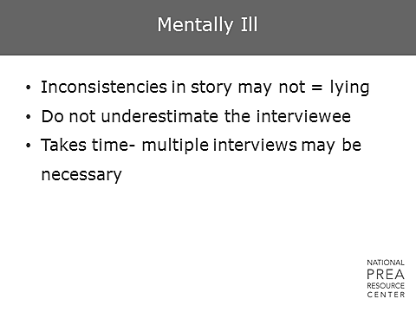  - Don’t assume inconsistencies in a story from a mentally ill inmate mean that he or she is lying. Be persistent and continue to ask the necessary questions that will allow you to get the information you need.  - Don’t underestimate the inmate. A mental illness does not reflect on a person’s intelligence, so don’t assume a lack of intelligence or limitations in reporting.  - Be prepared to follow-up with the inmate . Take the time necessary to get the information. | Mentally Ill
1 min | What is an Interrogation?  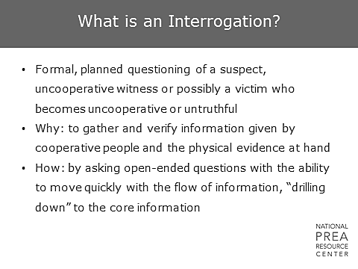  After you are comfortable with the information you have gotten from your cooperative victim and cooperative witnesses, you will want to interview the people involved in your investigation that may not be so cooperative or ones who have a history or being untruthful.  - The suspect in your case should be the last person you interview. You may need to go back to the victim or previous witnesses after your interview with the suspect, or your suspect may identify more witnesses for you to interview.  - As with your victim, you want to start by asking open ended questions and then become more specific as the conversation flows. You want to gather information that can be corroborated or proven inaccurate.  - The interviewer may be less supportive of an interviewee during an interrogation or a “hard interview.” | What is an Interrogation?
10 min | Interrogating  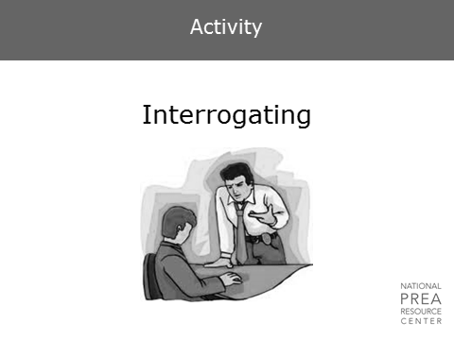 | Activity: Interrogating  Break the class into the most recent groups of three people. Have them spread out around the room. This time, ask trainees to select a suspect, an investigator, and an observer. Use the scenario depicted in the video of the female offender who became involved with a Captain, and interrogate him. Make use of the notes you took in the victim interview for the same scenario. The two trainees who are not doing the interviewing should take notes and give honest and constructive feedback to the interviewer, based on the information discussed in this module.  Interview for 5 minutes and then receive feedback for 5 minutes.
1 min | Techniques for Interviewing Your Suspect  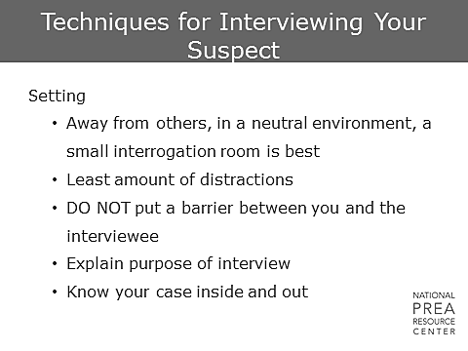  The techniques for interrogating a suspect are similar to the techniques for interviewing a victim or witness. Explain the purpose of the interview and take the time to build a rapport if it suits your purposes.  Make sure you have researched your suspect’s history before you interview them, both inside and outside the prison if they are an inmate. | Techniques for Interviewing Your Suspect
2 min | Techniques for Interviewing Your Suspect  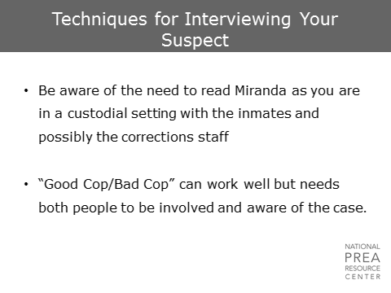  Don’t forget to use Miranda, when necessary. However, don’t feel the need to begin the interrogation with a Miranda warning. If building a rapport would be easier in advance of the warning, do so. A Miranda warning simply needs to be given before you ask any questions specifically concerning the case.  Miranda is for people who are not free to leave and are under hard interrogation. If you are interviewing a staff suspect and he/she can walk uninhibitedly out of the prison or building, you do not need to read Miranda at all.  Consider dual interviewing, but ensure you fully brief your partner before the interrogation or bring someone who already has knowledge of the case. Have a plan before you interview together. | Techniques for Interviewing Your Suspect  Insert agency processes regarding the use of a Miranda form or recording, etc.
1 min | Techniques for Interviewing Your Suspect  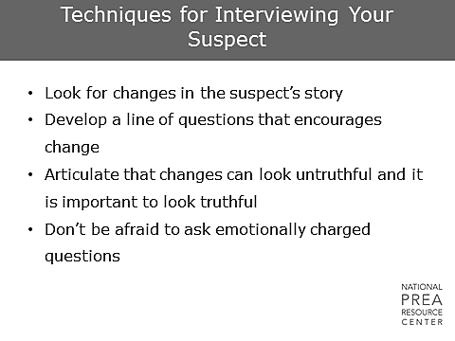  Once a suspect has given you their version of the story or has answered some of your questions, start to verify their comments or use facts you already have to highlight even small discrepancies and untruthfulness.  - Start by asking them to retell their story or asking for very specific information, e.g., detailed narrative of events (hour by hour) on a particular evening.  - Do not be afraid to ask questions that will make your suspect mad, e.g., “What will you buddies say when they hear you are forcing other inmates to have sex with you?” When people become angry, they often start to talk rapidly, and they confuse the lies already told. Their emotion takes over. | Techniques for Interviewing Your Suspect
1 min | Techniques for Interviewing Your Suspect  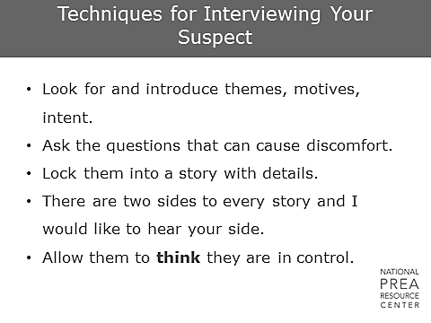  Ask the questions that will get you information on motive and intent.  - As the suspect answers your questions, make sure you document specifics on time, location, reasoning, etc. The more information you have, the easier it is to check for consistency across the suspect’s story. If he/she begins by denying sexual contact, an admission of contact in any form is a place to start.  - You can also work to convince the suspect that you’re on his/her side, and that you need information to help clear the suspect’s name. Don’t let your pride get in the way of using a suspect’s arrogance against him. Let the suspect think that he/she is in control. Feel free to play stupid or ignorant if that is helpful to getting information. | Techniques for Interviewing Your Suspect
1 min | Techniques for Interviewing Your Suspect  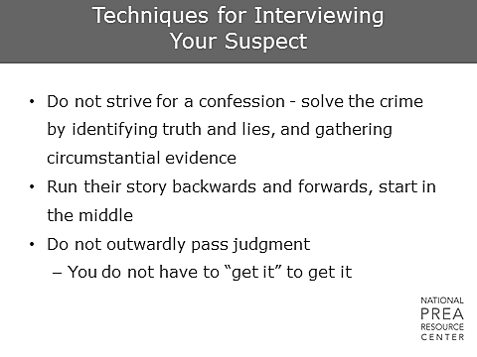  Don’t focus on getting a confession. Instead, focus on gathering as much information as you can, which will increase your chances of finding inconsistencies.  - Run through the suspect’s story from a variety of different perspectives. Have the suspect tell the story from the end and go backwards, or start in the middle. This will make it more difficult for him/her to maintain a lie.  - Don’t outwardly pass judgment – this will only shut down your suspect. Suspects don’t need to know what you really think of them. You only need to do your job and collect the information. | Techniques for Interviewing Your Suspect
1 min | Past Complaints - Same Staff  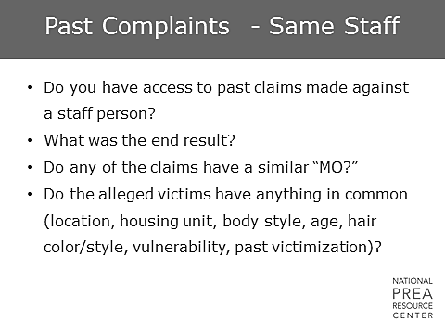  If the allegation involves a staff person, look at the history of allegations involving that staff member.  - Were other claims made against him/her?  - Were they similar in nature in victim characteristics or actions alleged? What were the findings? | Past Complaints - Same Staff
1 min | Past Claims - Same Staff  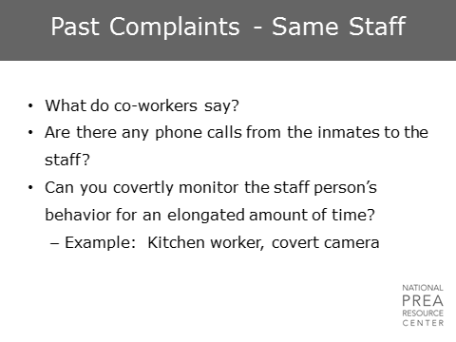  Talk to the investigators who were on those cases. Talk to other staff members who have worked with that staff person.  - What are their thoughts?  - What behavior have they observed?  Is there other evidence of a relationship? Look for video where the staff/inmate may have brief contact, share a phone call, or exchange letters or contraband.  Is it possible to covertly monitor the staff member’s behavior? What are the procedures for setting up a covert camera? We’ll talk about this in a second. | Past Complaints - Same Staff
1 min | Credibility Assessment  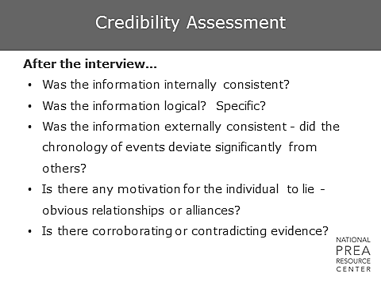  Once you’ve conducted your interviews and interrogations, look at the accounts of the incident in isolation in comparison to one another and in comparison to the internal workings of the facility.  - Are they internally consistent?  - Are they logical?  - Are they specific?  - How do they differ?  - Is there any way to corroborate any of the details in the stories?  - What motivation is there for someone to be lying? Were policies followed? | Credibility Assessment
1 min | Covert Operations  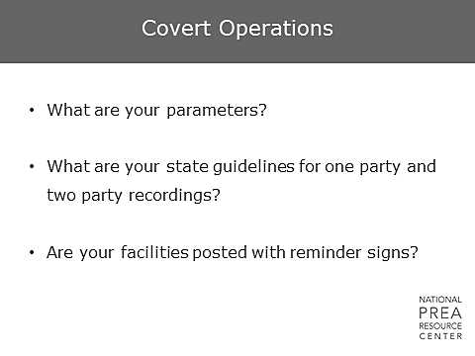  How does one conduct a covert operation inside a facility? What are the processes you have to go through?  Can you listen to covert audio with one person’s knowledge, or does everyone being recorded have to be aware? Can you conduct video surveillance with no one’s permission (except your supervisor’s)? | Covert Operations  Optional Activity: Pair up the class and have them bullet a list of actions that must be taken. Then ask people to share with the class.  Be prepared with your agency policy and procedures to answer questions.
1 min | Covert Operations  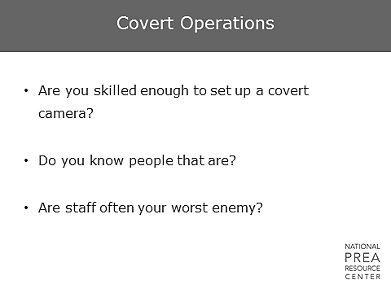  Once you are given permission to conduct a covert operation, what do you do then?  - Are you skilled enough to set up a camera yourself? Where can you get help with this?  - What will staff do if they find you trying to set up a camera? Do you have a reason for your presence there? Can you go through other channels? | Covert Operations
1 min | Covert Operations  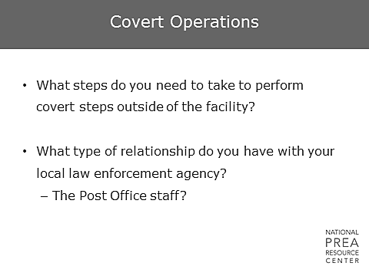  What about covert operations outside of the facility? Do you know the processes through which you have to go to set this up? What kind of relationship do you have with your local law enforcement, and how can they help?  If you believe that in a staff/inmate case, a post office box is being used or mail is being dropped off at a specific post office, ask your local postmaster for assistance. He/she can help get post office box subscriber info. Often there are cameras on the post office and the outside drop boxes. | Covert Operations  Optional (if time): Pair up the class into the same groups and have them bullet a list of actions that must be taken. Then ask people to share with the class.  Be prepared with your agency policy and procedures to answer questions.
1 min | Systemic Issues  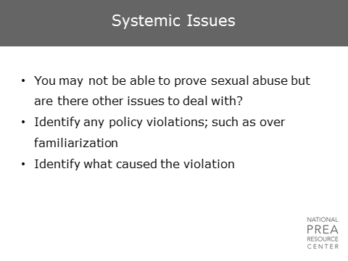  Many allegations in this area may be difficult to prove.  However, even in the event that you are unable to substantiate an allegation, you may still be able to identify policy violations that occurred and require sanctioning. Additionally, you should always work to identify actions that could be taken to enhance sexual safety.  - Are there isolated areas or blind spots that you discovered during your investigation that need to be addressed?  - Are there areas of policy that should be revised or trained to?  - You will be participating in incident reviews per PREA standard 115.86. What can you bring up during this review to improve the operations of your agency? | Systemic Issues
1 min | Systemic Issues  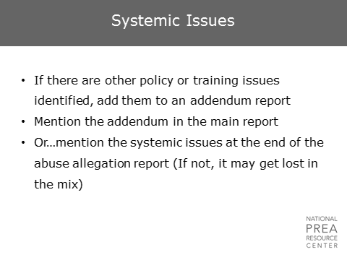  Include these thoughts in an addendum report or at the end of your main report to ensure they are recorded for future use. | Systemic Issues
1 min | Practice... Practice… Practice    Ultimately, practice is what improves your interview skills. Record your interviews for internal use. Listen to your colleague’s interviews to help them identify weaknesses and to learn from their strengths. Be proactive in improving your skills, and you will see results! | Practice... Practice… Practice
1 min | Questions?

