Module 6: First Response and Evidence Collection: The Foundation for Successful Investigations

Time: 8:45 a.m. – 11:00 a.m. (2.25 hours)

Training Objectives:
- Describe the dynamics of sexual abuse and sexual harassment in confinement settings.
- Identify best practice and policy requirements on first response procedures.
- Identify best practice and policy requirements on evidence collection in confinement settings, per the requirements of 115.(3)34.

Materials Needed:
- Easel pad and markers
- PowerPoint® player/machine (laptop computer and LCD projector)
- Screen or monitor
- Handout: Department of Justice definitions. Refer to “PREA Definitions” attachment.
- Handout: State statutory language defining sexual assault (prepared by trainer).

Training Tips:
- The purpose of this module is to provide participants with information on the dynamics of sexual abuse and sexual harassment in confinement settings; best practice and PREA standard requirements for first response; and evidence collection techniques in confinement settings per PREA standard 115.(3)34 requirements.
- Modify this module to address the specific needs of the investigators in your agency. Insert agency policy as suggested throughout the module. If investigators only conduct administrative investigations, target sexual harassment investigations for greater discussion. However, do not remove the evidence collection techniques. These are important both in the event that a sexual abuse occurs, and to meet the requirements of PREA standard 115.(3)34.
- An experienced investigator is an asset as a presenter or co-presenter for this module. Ask them to prepare anecdotes and lessons learned from their own experiences in advance of the training to share throughout the training. Additionally, ask the participants to speak up when they have a relevant experience to share. While presenting this Module and Module 7, it is important to recognize and emphasize the experience of your participants and give them an opportunity to learn from one another.

- Prior to the training, the trainer should select two approximately five-minute video clips that demonstrate the reality of sexual abuse in correctional settings. The video that is provided in the curriculum is Turned Out: Sexual Assault Behind Bars and is available at the following link: https://vimeo.com/308469127. This full video is approximately fifty-five minutes long, so the trainer will need to watch the video and select two appropriate five-minute segments prior to the training.
- Be advised that this module may contain material that utilizes concepts and language that may be upsetting or difficult for some participants. This may include statements referring to genitalia, sexual harassment, sexual abuse, trauma and suicide. Videos used may also contain profanity and graphic language, including references to sexual abuse and trauma. Please review all materials prior to using to ensure they are appropriate for use in your agency and make substitutions where needed. You should also consider providing a general notice to participants at the beginning of each training session.
- Please note that this module was developed specifically for facilities that use the Adult Prisons and Jail or Juvenile PREA Standards. Facilities using the Community Confinement or Lockup standards should review all standard references to ensure that the content and language is appropriate for their facility type and inmate/resident population and adjust the material as needed to their specific circumstance.

Time | Lecture Notes | Teaching Tips
 | First Response and Evidence Collection: The Foundation for Successful Investigations |   First Response and Evidence Collection
1 min | Objectives  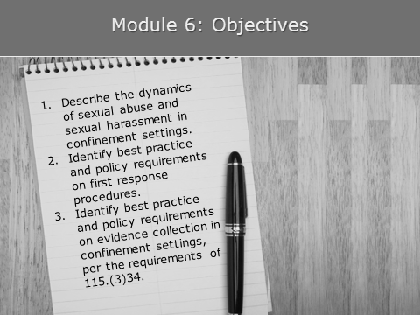 | Objectives
1 min | What are the goals of an investigation?  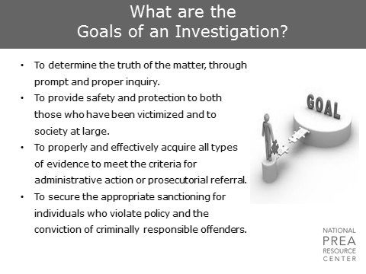  Your primary goal as an investigator is to determine the truth, as much as is possible. You are charged with ensuring the safety of the offenders in the care of your agency and of society at large by ensuring you collect the evidence needed for administrative action or prosecutorial referral.  The ultimate goal is to ensure that those individuals who violate policy or law are appropriately sanctioned through the agency disciplinary system or through the criminal justice system. | What are the goals of an investigation?
2 min | Types of Allegations  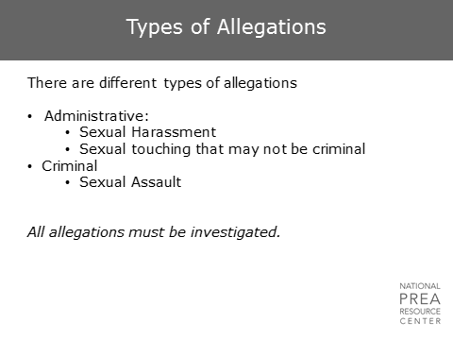  In this agency… | Types of Allegations  Insert agency process regarding who handles different types of allegations (e.g., administrative allegations are investigated within the facility; criminal allegations are referred to law enforcement).
1 min | Continuum of Inmate-on-Inmate/Resident-on-Resident Sexual Abuse  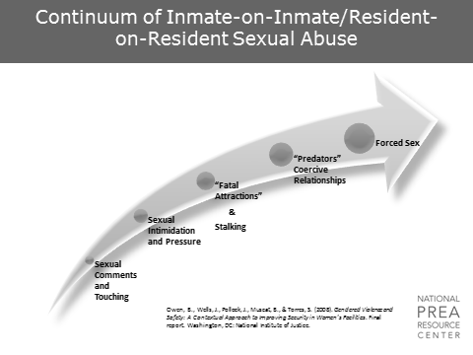  This continuum of sexual abuse was developed from research conducted by Dr. Barbara Owen and Dr. James Wells on sexual safety in women’s facilities. However, it applies to both male and female inmates as well as adult and juvenile facilities. The continuum ranges from sexual comments and touching to forced sex or sexual assault.  The least serious form of sexual victimization described in the interviews was verbal, such as  - Referring to an inmate’s/resident’s body  - Making sexual innuendos  - Sexual “horseplay” or touching someone’s body in a non-violent but uninvited and unwanted manner  This is followed by sexual intimidation, which  - Occurs when someone is asked repeatedly to become involved romantically or sexually with another inmate.  - Has been hard to define. In discussion with residents/inmates, many stated that it is “hard to know” if individuals were coerced or entered into such relationships voluntarily.  A particular type of sexual pressure or intimidation occurs in so-called “fatal attraction” cases or “fatals,” named after the movie of the same name that involved a stalker who would not give up her quest for a love interest. In these cases, one person is enthralled with another and seeks a sexual liaison at any cost. In some instances, participants described certain individuals in the prison as “predators.” These descriptions were not common but they were mentioned.  At the extreme end of the coercion continuum is forced sexual intercourse or sodomy. | Continuum of Inmate-on-Inmate/Resident-on-Resident Sexual Assault  Owen, B., Wells, J., Pollock, J., Muscat, B., & Torres, S. (2008). Gendered Violence and Safety: A Contextual Approach to Improving Security in Women's Facilities. Final report. Washington, DC: National Institute of Justice.
1 min | What is Reportable?  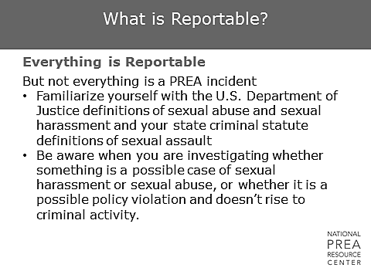  What are allegations you may see that do not fall into these categories? How should those allegations be treated? What about such behaviors as hand holding? This action does not fall into the definition of sexual abuse. However, it may indicate some coercive behavior. It should be treated as a policy violation, but investigators should pay attention for additional indications of coercion, such as sexual pressuring. | What is Reportable?  Read the definitions of sexual harassment and sexual abuse and your state statutory language of sexual assault.
1 min | Types of Investigations  Sexual Harassment  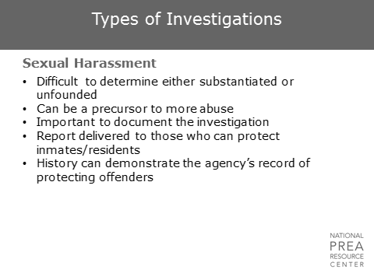  On one end of the continuum are sexual harassment incidents. These cases  - Will probably be the most common type of allegation received.  - Perhaps are the most difficult type of allegation to investigate.  - Are extremely important because predators will typically try to develop a relationship with their target before an incident of sexual abuse.  Additionally, sexual harassment can be graphic, vulgar, and violent, and can be traumatizing and damaging to the victim. | Types of Investigations  Consider inserting agency data demonstrating the frequency of sexual harassment allegations in the agency.
2 min | Dynamics of Sexual Harassment  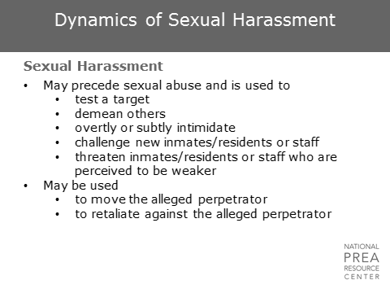  Sexual harassment is often a way for a sexual predator to determine whether a target is vulnerable and whether a target would report the incident. It is recommended that investigators  - Treat sexual harassment cases like any other case involving bullying or threats where the individuals need to be kept separated.  - Separate the alleged victim from the suspect to ensure there is no opportunity for the harassment to develop into something more serious.  Additionally, separation will provide the agency with evidence of proactive measures taken to protect potentially vulnerable inmates/residents.  Frequent sexual harassment aggressors  - Are often voyeurs and exhibitionists, which may include masturbating in front of others during count or security checks.  - Often have poor impulse or anger control, demean others with profanity and threats, and harass and solicit sex when challenged or angry.  Allegations of sexual harassment may also  - Be used by inmates/residents to separate themselves from others as a result of gambling or other debts.  - Be used by inmates/residents as retaliatory measures against staff.  Take this into account when investigating the allegations, but do not let it overshadow the agency’s need to protect inmates and prevent future abuse. Every allegation – including sexual harassment – needs to be thoroughly investigated, with a written report. | Dynamics of Sexual Harassment
2 min | Types of Investigations  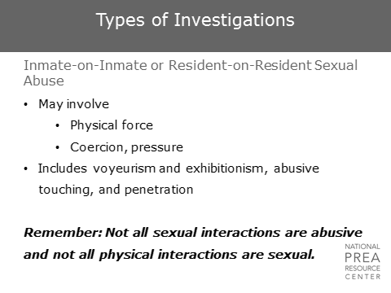  These types of allegations  - Often require attempts to determine the difference between consensual and coercive sexual activity between inmates/residents.  - Require investigators to determine the relationship between the alleged victim and suspect through interviews and evidence collection.  As before, separate the alleged victim from the suspect regardless of whether the allegation is substantiated. Although inmates/residents may attempt to manipulate the system, it is important that the agency prevent sexual abuse and perform their due diligence in protecting inmates/residents than it is for all those who attempt to manipulate the system to fail.  The population of your facilities will dictate the types of allegations you receive. Women’s facilities, for example, may have more allegations due to the higher number of relationships existing in the population.  Although it is important to take sexual abuse allegations seriously and be aware of what could be indicative of coercion, not all sexual interactions are abusive, and not all physical interactions are sexual. This will be discussed in more detail later in this module. | Types of Investigations  Consider inserting agency data demonstrating the frequency of sexual abuse allegations in the agency.
1 min | Dynamics of Sexual Abuse  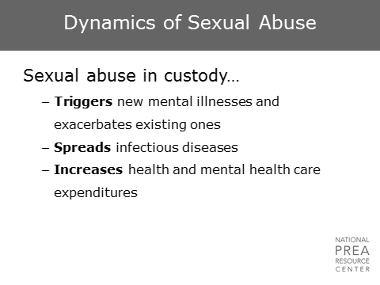  Sexual abuse in custody impacts much more than the individual health and well-being of the victim, although that is an important concern. Sexual abuse also  - Spreads infectious diseases within the confinement population  - Spreads infectious diseases, after release, within the community at large  - Increases the costs of public health and mental health care as the victims struggle with the impact of the trauma. | Dynamics of Sexual Abuse
1 min | Dynamics of Incarceration  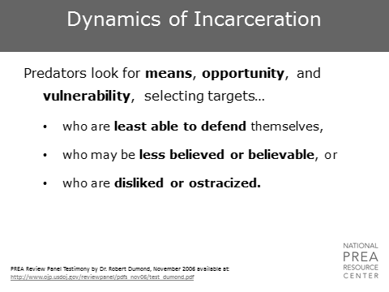  Consistent with the Bureau of Justice Statistics’ data, vulnerable inmates/residents often are those who are both physically and socially vulnerable: those smaller and/or weaker than the aggressor and those that are socially isolated.  - Reporting cultures can decrease the vulnerability of inmates/residents by removing the vulnerability factor related to the perceived credibility of reports.  - In cultures where all allegations are investigated, inmates/residents will have equal access to support from the facility, regardless of their relationship with staff or their level of social isolation. | Dynamics of Incarceration  PREA Review Panel Testimony by Dr. Robert Dumond, November 2006.  Refer to “Robert Dumond Testimony” attachment
7 min | 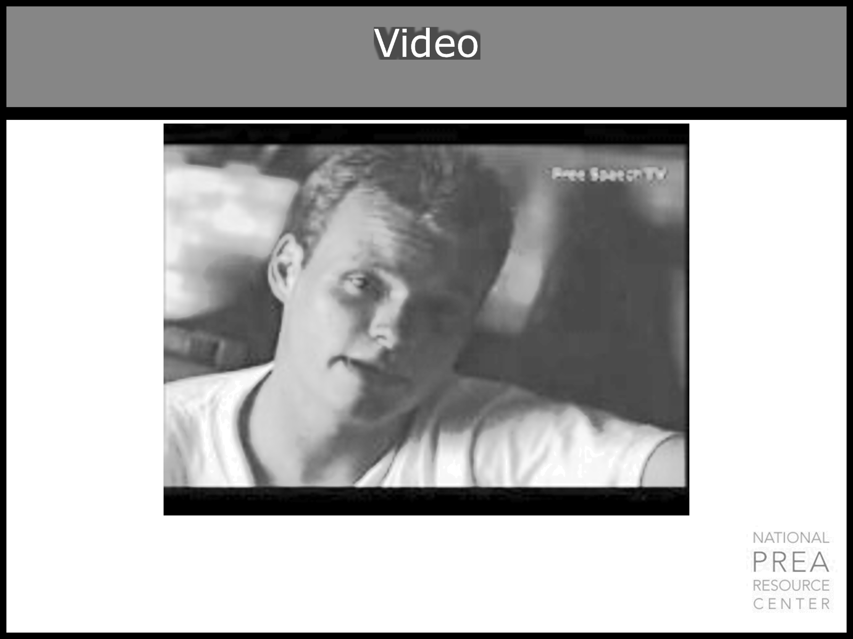  We’re going to start with a video clip with some material of a pretty graphic nature.  Scenario  So, let’s say your brother-in-law borrowed $1,000 from a friend, and he’s down on his luck and can’t repay the money. What if the friend told him, you have three choices: (1) you repay the money; (2) Don’t repay and I beat you up; or (3) Don’t repay and I’ll force you to have sex with me.  How will law enforcement respond if your brother-in-law reports this situation? Do you think they will look at this case a little differently than we look at this situation in institutions? Is there really a difference? What’s the difference?  The difference is your brother-in-law is outside in the community, and the inmate is in a facility. |   Show a video clip here to demonstrate the reality of sexual abuse in correctional settings. One possible documentary is Turned Out: Sexual Assault Behind Bars. This video is available online: https://vimeo.com/308469127  Ask: Did you find anything that has been said in this video to be inaccurate? Maybe on a smaller or larger scale than what was shown? What are the dynamics that exist in our facilities?  Discuss this scenario, highlighting how this situation would be different in a facility versus in the community.
1 min | Dynamics of Incarceration  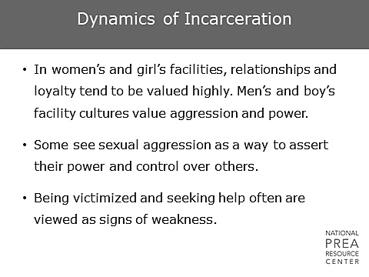  The dynamics of sexual abuse vary depending on the population of the facility.  - Girls and women generally value relationships and many of the allegations revolve around those relationships.  - Men’s and boy’s facilities tend to have incidents with more aggression.  Typically, male inmates tend to engage in sexual abuse due to  - A higher sex drive  - Forced abstinence  - The need to pursue power or control over weaker inmates/residents  It generally does not occur because of a need for connection, love or romantic feelings.  Women  - May be more likely to report sexual abuse than men.  - May have unique challenges identifying their own abuse due to their histories of trauma and the importance of relationships and connections in their lives.  - Have different pathways to criminality which will be discussed later.  It is never easy for anyone to report sexual abuse due to feelings of shame, embarrassment, self-doubt, fear, and the inevitable stigma. | Dynamics of Incarceration
1 min | Dynamics of Incarceration  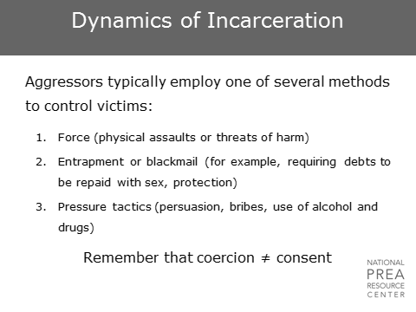  We frequently are aware of situations in which an offender consented to sex with the perpetrator the first time but tried to refuse on a subsequent occasion. Some offenders may voluntarily enter into a sexual relationship in exchange for protection, canteen, etc., but change their minds after a while. Staff members often find it hard to feel compassion for such victims. Those are difficult cases to investigate and prosecute.  But investigators need to respond as vigorously and sensitively as they would in any other case. If we do not, the perpetrators will continue and find more victims. Even if a criminal prosecution is not possible, a determination of guilt in a disciplinary proceeding can help stop a predator from victimizing future inmates/residents or staff. | Dynamics of Incarceration
7 min | Video |   Play another video clip.  Consider a different segment from Turned Out: Sexual Assault Behind Bars:  https://vimeo.com/308469127  Ask if anyone has any comments.
2 min | Dynamics of Incarceration  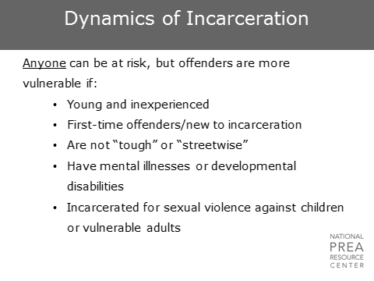  All offenders have the potential to be vulnerable to abuse, but there are certain characteristics that make someone particularly at-risk. As an investigator, it is important to know the dynamics of sexual abuse to be able to fully understand what may have actually happened.  Additionally, it’s important to be aware of these vulnerabilities to ensure certain types of allegations are not ignored. Most agencies have offenders with mental health disorders who submit numerous reports. For example, the inmate/resident who will call twice a week claiming that the warden is sneaking into his cell at night through the air vent to perform oral sex on him.  Do you investigate these claims? Yes. Every single one.  Does it need to take long? No. On many of these allegations, you’ll have videos that you can check, or you can place the inmate/resident under ongoing observation. However, each allegation needs to be investigated because these are vulnerable individuals who perpetrators will target for victimization specifically because they know that their allegations are less likely to be taken seriously. | Dynamics of Incarceration
1 min | How I Got Here  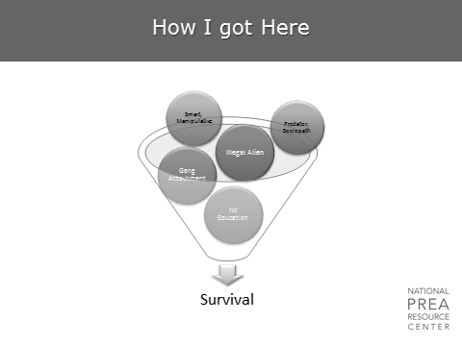  It is equally important for investigators to understand the dynamics of offenders’ lives and their life pathways to criminality before they ended up in custody. Offenders may  - Be lacking formal education which is important to consider when determining how to communicate with them.  - Have gang attachments or they may be illegal immigrants, which will impact the dynamics of their relationships within their facility.  - Be smart, manipulative, predatory, or even sociopathic.  However, it is important to remember that the characteristics they have and the pathways they may have followed were probably developed as a means of survival. | How I Got Here
1 min | Pathways for Women  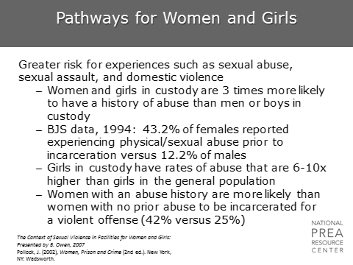  As we discussed earlier, many inmates have been previously victimized. Male and female inmates have often been victims of emotional, physical, and sexual abuse by trusted persons at a much higher rate than the national average.  This history of abuse has been shown to actually contribute to the women’s and girl’s likelihood of ending up in the criminal justice system. | Pathways for Women  The Context of Sexual Violence in Facilities for Women and Girls, Presented by B. Owen, 2007  Pollock, J. (2002), Women, Prison and Crime (2nd ed.). New York, NY: Wadsworth.
1 min | How I Got Here  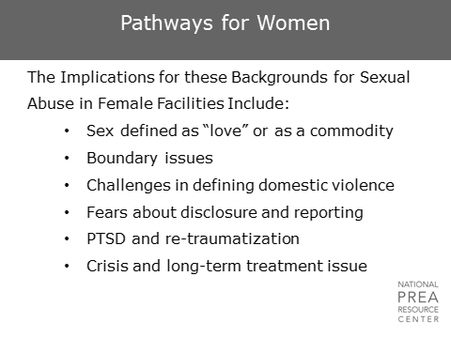  These pathways are relevant to the dynamics of sexual abuse in confinement. Women in confinement may:  - Have a different understanding of sex and love than most of the general population due to abuse histories.  - Have such long histories of abuse that they may not recognize abuse in certain types of relationships. For example, sex in exchange for protection or for commissary items may not be seen abnormal or coercive.  - See sex purely as a commodity.  This may impact their relationships with staff as well, particularly with regard to their boundaries and the relationships they attempt to develop. Individuals with histories of abuse are much more likely to suffer from long-term trauma issues that may influence their behavior day-to-day, as was discussed in Module 4.  Many of these women who have suffered physical and sexual abuse in the past may be asking “why do you care now? Why didn’t anyone care the first or the second or the third time it happened out in the community?” | How I got Here  Source: The Context of Sexual Violence in Facilities for Women and Girls: Presented by B. Owen, 2007  Ask: Should this impact how you interview them? How might a history of abuse impact the way they see you?
1 min | Protective Pairing  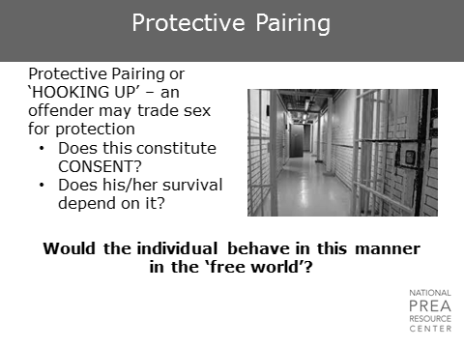  “Protective Pairing” is a term used to describe when sex is exchanged for something, such as protection or commissary. Is the sex in this situation consensual or coercive?  Ultimately, the question to ask is whether the individual in question would have behaved that way in the free world. If you released all the men in your institutions back out in the community, would all of the men who are involved in sexual relationships with other men inside the facility find men in the community to partner with? Pairing up with someone for safety does not mean consent any more than a small business giving a percentage of their profits to the mafia every month in exchange for protection is “consensual.” It’s important that we don't view life in custody as different from life on the street. We can't start applying different sets of rules. If the alleged victim exchanged sex for protection, perhaps the facility needs to find a better way to protect the inmates/residents.  Women will often create a “family” within the facility. This family will provide support and security for one another. Juvenile females, on the other hand, tend to be more aggressively focused on relationships with men, which leads to more altercations between juvenile females than adult females. | Protective Pairing
1 min | Continuum of Staff Sexual Misconduct  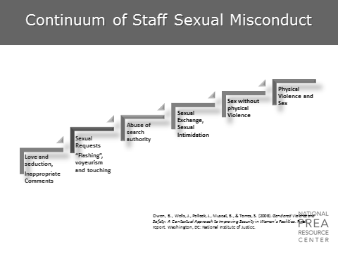  Similar to the continuum of sexual abuse in confinement, there is also a continuum specific to staff sexual misconduct.  It begins with love, seduction, and sexual harassment. It increases to sexual requests; voyeurism and exhibitionism; abuse of search authority; sexual intimidation; sex without physical violence; and, finally, sex with physical violence. | Continuum of Staff Sexual Misconduct  Owen, B., Wells, J., Pollock, J., Muscat, B., & Torres, S. (2008). Gendered Violence and Safety: A Contextual Approach to Improving Security in Women's Facilities. Final report. Washington, DC: National Institute of Justice.
1 min | Staff Offenders: Always an Unequal Relationship  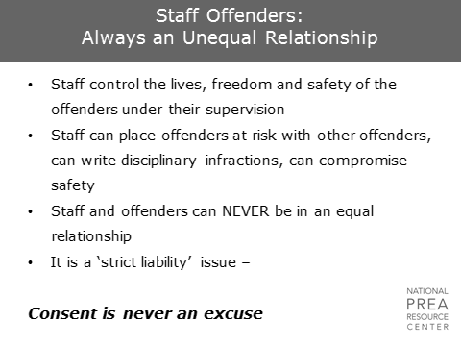  - Staff and offenders can never be in an equal relationship.  - It is a ‘strict liability’ issue. Consent is never an excuse.  The dynamics of staff sexual misconduct are important for investigators to understand. “Consent” between staff and offenders is impossible in the same way that consent between adults and minors is impossible. Both acts are clearly illegal in all 50 states.  Unless the inmate/resident has forcibly sexually abused the staff member, the act and the repercussions are always the staff member’s responsibility. A staff member has control over the lives of inmates/residents.  - Control over offender physical safety  - Control over access to basic needs  - Influence over impact parole.  Think about your own relationships. Once you are in a relationship with someone, there are certain risks to ending the relationship.  - You might lose access to a car if your partner used to drive you places.  - Your partner might complain about you to your friends, hack your email, or egg your house.  - You may have to deal with children and custody decisions.  In a facility, if you’re an inmate trying to figure out how to end things with a staff member, think about the risks you are taking and the potential repercussions you could face if the staff member is vindictive. The power imbalance is too great for the inmates/residents to be able to consent to any sexual act. Even if the inmate/resident states that they consented, lies about it during an interview, or refuses to cooperate with the investigation, the inmate/resident is still a victim and cannot in any way be held responsible. | Staff Offenders: Always an Unequal Relationship  Ask: Do you have prosecutors who don’t entirely agree with this? What about line staff? What about cases of staff sexual misconduct involving female officers and male offenders? Is there pity for that female officer?  If the answer is no, state that it has taken a long time to get there in the field. There is often the perception that the female staff and the male inmate are in love, and therefore it can’t constitute sexual abuse, and we shouldn’t prosecute.  If the answer is yes, discuss how that impacts investigations.
15 min | Video | Play the video scenario where offenders discuss their experiences with staff sexual misconduct.
5 min | Staff and Offenders: Always an Unequal Relationship  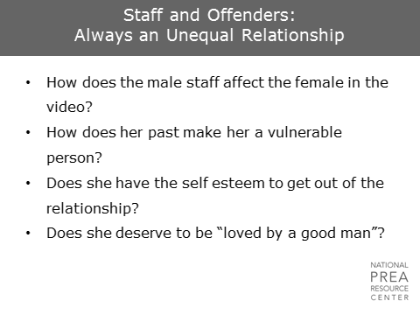 | Staff Offenders: Always an Unequal Relationship  Ask the class to respond to the questions on the slide. How can a “willing” relationship between an inmate and a staff person be unequal and coercive?  Ask: How many of you have worked with or dealt with prostitutes on the street? How many of you understand the choices they make?
1 min | Reports of Sexual Abuse and Sexual Harassment  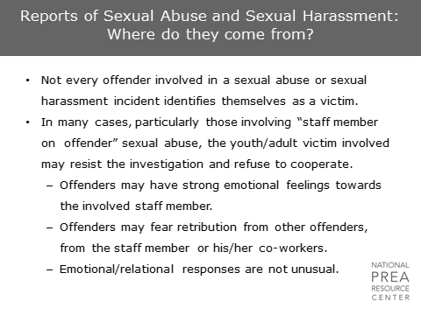  Be aware that, in cases in which the inmate/resident does not report, you may not always have a cooperative victim.  - Victims of sexual abuse or sexual harassment may not always consider themselves victims. This is particularly true in cases of staff sexual misconduct in which the victim may have feelings for the staff member.  - Victims may fear retaliation if they cooperate.
30 sec | First Response  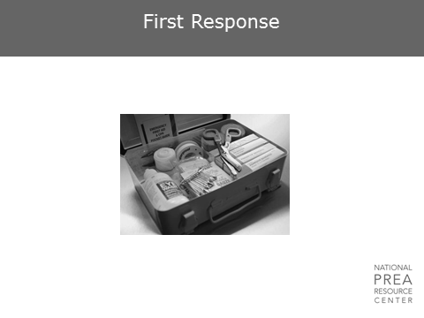  Now that we have discussed what allegations we can expect and the dynamics that result in those allegations, let’s talk about what happens once an allegation is made. | First Response
10 min | Video: First Responder | Play this scenario: A female officer acts as a first responder to a male inmate’s allegation.  Discuss: How is this scenario different from first responses typically that typically go on at our facility/ agency? What did this woman do that was good? What would you have done differently?
1 min | What is the Role of a First Responder  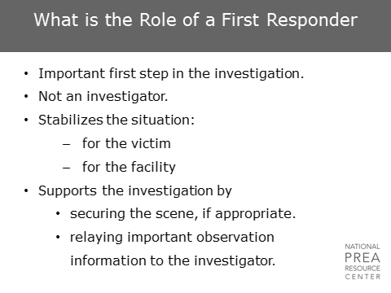  First responders play an important role in any investigation. They  - Stabilize the situation  - Secure the scene  - Provide important information to investigators  However, there are important distinctions between their role and the role of the investigator, and it is important that there be clarity for all parties on their roles. | What is the Role of a First Responder
2 min | - Agency Policy  - Policy within this agency dictates… | Insert appropriate agency policy here  - Responsibilities of the first responder  - Process by which allegation reaches investigator  - Types of allegations investigated
1 min | The Event is Reported  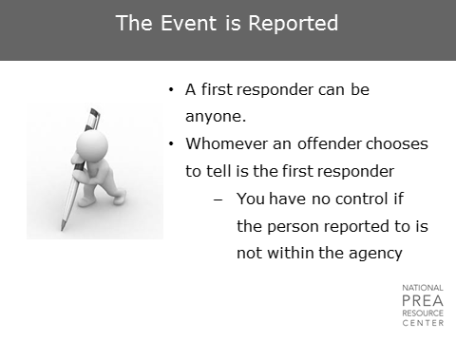  Who is a first responder? Anybody – the agency has no control over this. However, you do have control over actions taken through policy and training.  If an inmate reports to a line staff member and the staff member dismisses the allegation, what will that do to the case down the road? The victim will be substantially less likely to cooperate with investigators and give the full story. | The Event is Reported  Insert information on agency training plan
1 min | Reports of Sexual Abuse and Sexual Harassment  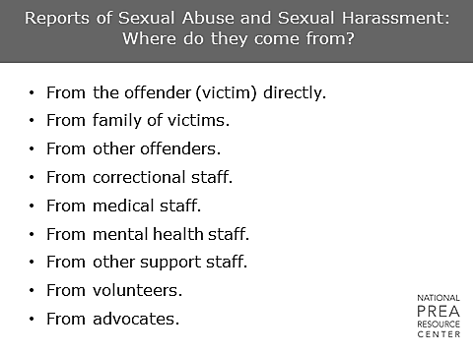  Where do reports of sexual abuse and sexual harassment come from?  Reports of sexual abuse and sexual harassment can come from anywhere. This lists some of the more typical ways incidents are reported. | Reports of Sexual Abuse and Sexual Harassment
2 min | First Responder’s Role: Interacting with the Victim  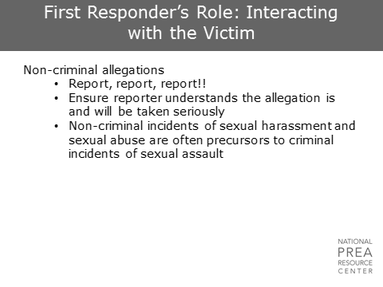  These will probably be the most common type of allegation received. The role of the first responder in these instances is  - To ensure the report makes its way to the appropriate parties for investigation.  - To ensure that the person reporting understands that their allegation will be taken seriously, and does not feel dismissed or ridiculed by the staff person to whom they reported.  As we discussed previously, non-criminal incidents of sexual harassment and sexual abuse can often be precursors to more serious incidents of sexual abuse, and therefore need to be taken seriously and addressed. | First Responder’s Role: Interacting with the Victim  Insert agency policy regarding relevant first responder responsibilities for responses to both incidents of sexual abuse and incidents of sexual harassment.
1 min | First Responder’s Role: Interacting with the Victim  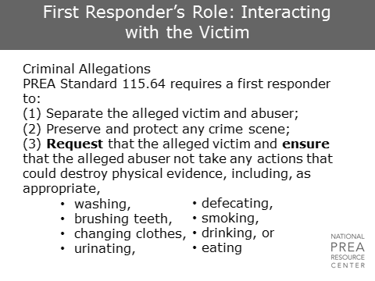  The PREA standards require a first responder to take these steps:  - Separate the victim from the abuser  - Preserve the crime scene  - Ensure that any physical evidence is not destroyed.  Additionally, they must offer the victim the opportunity to have a sexual assault forensic medical exam if the allegation is within the time period specified by the forensic protocol. Note that this exam cannot be forced; the alleged victim must consent. | First Responder’s Role: Interacting with the Victim  Insert agency policy regarding relevant first responder responsibilities.  Insert guidance provided by agency protocol regarding the period of time after an alleged incident that a victim will be offered a forensic medical exam.
2 min | First Responder’s Role: Interacting with the Victim  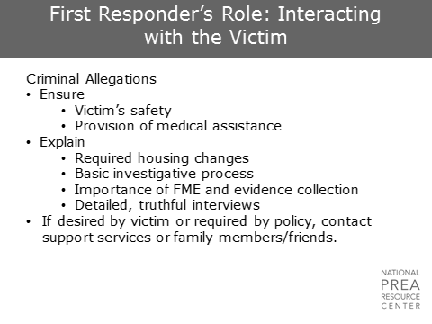  First responders should also  - Ensure that the alleged victim receives appropriate medical treatment  - Explain any necessary housing changes to ensure the alleged victim does not feel that they have been punished for reporting  - Explain the request to not destroy any physical evidence  - Provide any other necessary information regarding the investigation process to ensure the alleged victim feels comfortable. Note that an investigator or case manager will discuss these issues later in more depth, but the first responder should be prepared to provide any immediate information needed to the victim.  Do not contact family members of adult victims of sexual abuse unless the victim requests it or there is a specific need-to-know.  PREA standard 115.361 requires juvenile facilities to promptly report an allegation of sexual abuse to the alleged victim’s parents or legal guardians unless the facility has official documentation showing the parents or legal guardians should not be notified. | First Responder’s Role: Interacting with the Victim  Insert agency policy regarding relevant first responder responsibilities.  Only include this statement for agencies with adult populations.  Only include this statement for agencies with juvenile populations.
1 min | First Responder’s Role: Interacting with the Victim  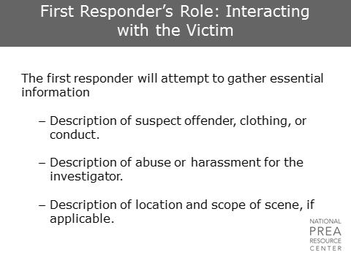  The first responder should also attempt to gather basic, essential information for communication to the investigator, security staff, and any other appropriate personnel. | First Responder’s Role: Interacting with the Victim  Insert appropriate processes for securing the crime scene.
1 min | First Responder’s Role: Interacting with the Victim  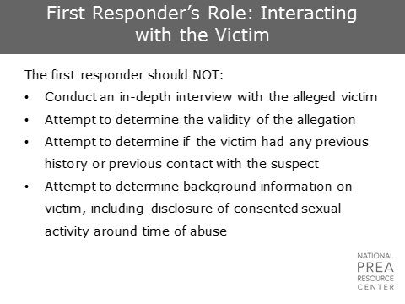  The first responder should not  - Conduct in-depth interviews or attempt to determine anything beyond the basic information listed on the previous slide.  - Attempt to determine the validity of the allegation.  - Play any role in deciding whether an allegation should be reported to investigators.  All allegations are referred to investigators, even if the first responder or his/her supervisor is convinced that the allegation is false. It is up to the investigator, and no one else, to investigate and make that determination. | First Responder’s Role: Interacting with the Victim
1 min | What Should a First Responder Record in Their Notes for the Report?  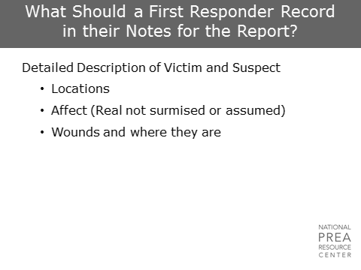  The first responder should prepare a report for the investigator that  - Includes their observations at the time of the response.  - Does not include the conclusions that the first responder came to based on his/her observations. For example, the first responder report could state external observations that the alleged victim was crying and shaking. The report should not state “assumptions” or “feelings/emotions” that are internal, such as the alleged victim was extremely upset and seemed terrified. | What Should a First Responder Record in Their Notes for the Report?  POSSIBLE ACTIVITY: Have someone (perhaps yourself) walk in the room acting in a certain way (could be laughing, then crying, then silent). Then have him/her leave. In small groups or with the person next to them, have trainees write down what they just saw in appropriate observational language.
30 sec | What Does Every Case Need To Be Successful?    What do you need so that every case you investigate is successful? | What Does Every Case Need To Be Successful?
1 min | What Every Case Needs  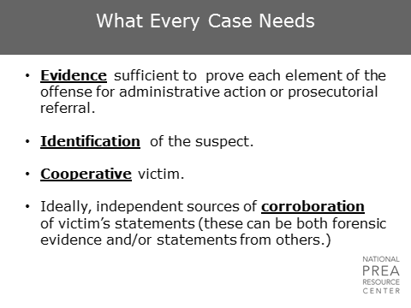  The case needs  - Enough evidence for administrative action or prosecutorial referral.  - An identified suspect and, ideally, a cooperative victim. Most prosecuting attorneys will not prosecute a case without a cooperative victim.  - Some independent sources of corroboration of the victim’s statements. These can be statements from others or forensic evidence. This is necessary to ensure the case is not a “he-said he-said” “she-said she-said” or “he-said she-said” case. | What Every Case Needs
1 min | What Every Case Needs  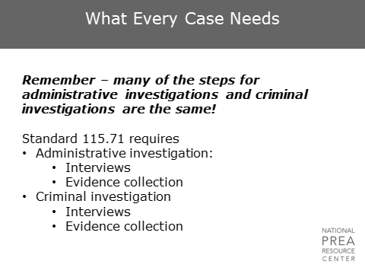  Do not forget that many of the steps for administrative and criminal cases are the same. In both cases, the investigator should be interviewing the alleged victim, suspect(s), and witnesses and collecting any evidence available. | What Every Case Needs
30 sec | What is Evidence?  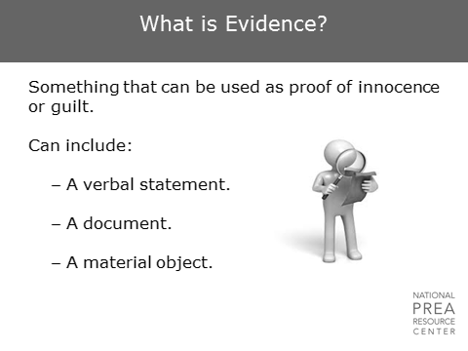  So what is evidence? Evidence is anything that can be used as proof of innocence or guilt. An investigator is looking for anything that will provide information one way or the other. | What is Evidence?
3 min | What Are Your Sources Of Evidence?   | What Are Your Sources Of Evidence?  Discuss. Write the class’s responses on an easel pad. Discuss how being in a correctional setting can be both advantageous – because there are sources of evidence here that are not in the community (e.g. video, logs) – and disadvantageous – because of the number of people living together in a small place and the risk of evidence contamination.
2 min | Sources of Evidence  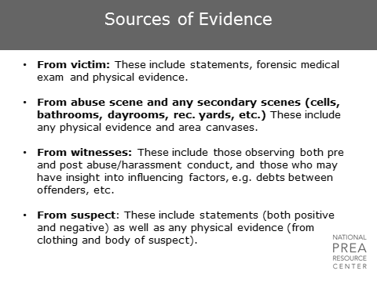  Sources of evidence come from a variety of places, and all possible sources should be checked during an investigation. Alleged victims can provide  - Verbal statements  - Forensic medical evidence  - Physical evidence that is not on their person including letters, video footage, and other forensic evidence they have collected themselves.  Any abuse or secondary scenes may have evidence including forensic evidence. The cell/room or office of the alleged victim or suspect may hold other types of evidence, including contraband.  Witnesses should always be interviewed. These do not need to be witnesses of the actual abuse but could be individuals who observed changes in the alleged victim’s/suspect’s demeanor, previous interactions, etc. Both staff and inmates/residents who may have insight into any influencing factors may be important witnesses.  Suspects may also communicate valuable information in interviews and may provide valuable physical evidence off their clothing or bodies either corroborating or contradicting the statements of the alleged victims. | Sources of Evidence
30 sec | Sources of Evidence  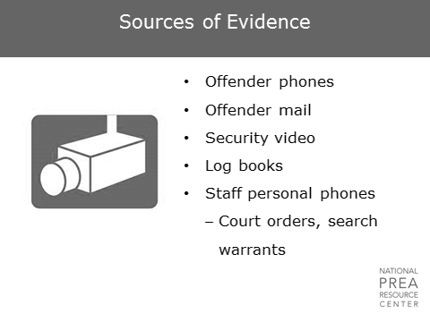  Additionally, always check phone records, recordings, mail, videos, log books, etc. In the event of an alleged staff sexual misconduct case, be aware of what you are able to search and when you’ll need a court order or search warrant. | Sources of Evidence
1 min | Credibility Assessment  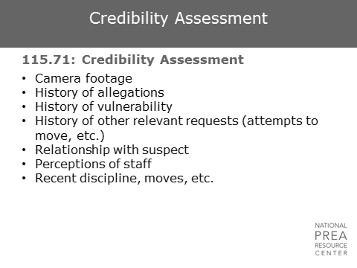  PREA standard 115.71 requires  - The credibility of an alleged victim, suspect, or witness to be assessed on an individual basis – and not based on the person’s status as inmate or staff.  - Investigators must include the basis of their credibility assessment in their reports.  As an investigator, ensure you are deliberate in documenting the methodology through which you determine the credibility of your alleged victims and suspects. In addition to evidence such as camera footage, the investigator will also want to look at the following to ensure the investigator fully understands the context in which the allegation exists. The inmate’s/resident’s  - History of allegations  - History of other relevant requests  - Recent disciplinary reports, etc.  - Relationship with the suspect | Credibility Assessment  The PREA Resource Center (PRC) provides additional resources for conducting credibility assessments during investigations. Participants should be encouraged to become familiar with these resources.  The resources can be found on the PRC’s website in the library.  Credibility Assessments: Best Practice Guidelines for Investigators can be found at this link: https://www.prearesourcecenter.org/resource/credibility-assessments-best-practice-guidelines-investigators.  Credibility Assessments: Q&A can be found at this link: https://www.prearesourcecenter.org/resource/credibility-assessments-qa
1 min | Sexual Harassment Cases – Considerations  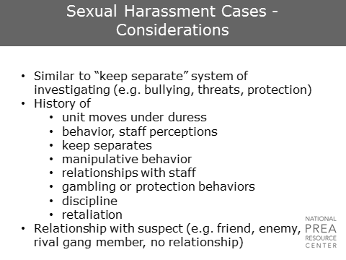  It may be helpful to consider sexual harassment cases to be within the same category as “keep separate” cases involving bullying, threats, and so on. Sexual harassment allegations are important to consider seriously, but are also areas where inmates/residents may attempt to manipulate the system if they are unhappy with their current living situation or need to separate themselves from someone to whom they owe a debt. Ultimately, the alleged victim’s past behavior and current relationships need to be considered. | Sexual Harassment Cases – Considerations
4 min | Pat-Down Search Cases – Considerations  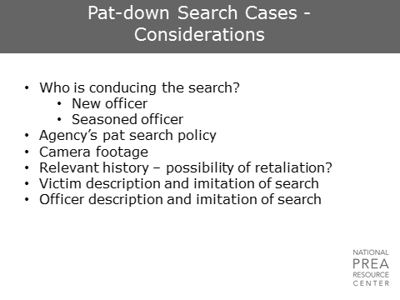  Allegations involving pat-down searches are common and may stem from a variety of areas. Often, new officers are more thorough in their pat searches than more seasoned officers because they have just received training. For inmates more used to pat searches conducted by seasoned officers, they may honestly feel that new officers are crossing a line in their searches. An agency may therefore see a spike in pat-search related allegations when new officers are introduced to the housing units.  However, some searches may actually be inappropriate. Training and supervisory observation are critical.  For these cases  - Investigators will need to be familiar with the agency pat-search policy.  - It may be helpful for pat-searches to be conducted in front of cameras by policy, if possible.  - Investigators should have the alleged victim demonstrate the search on himself/herself. Then have the suspect demonstrate the search on another staff member. This technique may provide valuable information.  - As with other allegations, the alleged victim’s relevant history and other influencing factors must be considered. | Pat-Down Search Cases – Considerations
1 min | Acquaintance Cases - Considerations  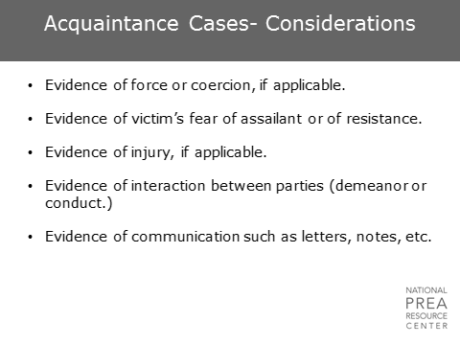  Cases involving individuals who know each other or who may have been in a relationship previously can be difficult, and an investigator will need to specifically look for  - Any evidence of force or coercion  - Evidence of injury  - Evidence of any fear or resistance on the part of the alleged victim.  Any information the investigator can collect on the relationship between the two parties and of specific past interactions between them is valuable. The investigator should particularly look for any actual documentation of communication such as letters or notes. | Acquaintance Cases - Considerations
1 min | In the event of a sexual assault…  GLOVE UP!  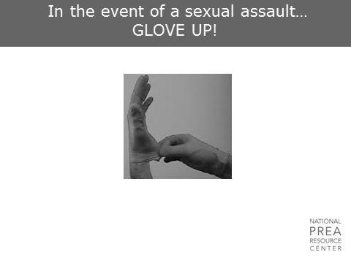  Evidence collection in cases of sexual assault involves unique processes, and it is important for investigators to be familiar with these processes. These cases may be rare, but when they do occur, you only get one chance to preserve and collect the evidence correctly. | In the event of a sexual assault…
1 min | Facility Crime Scene  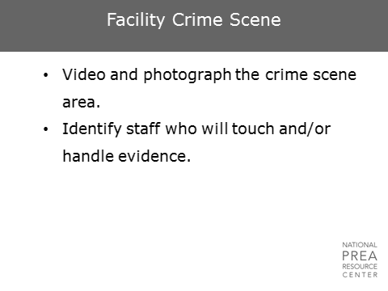  Start taking notes immediately, but do not forget that notes are discoverable in criminal proceedings. Only put facts and observations in notes. If feasible, video and photograph the entire crime scene. | Facility Crime Scene
1 min | Crime Scenes  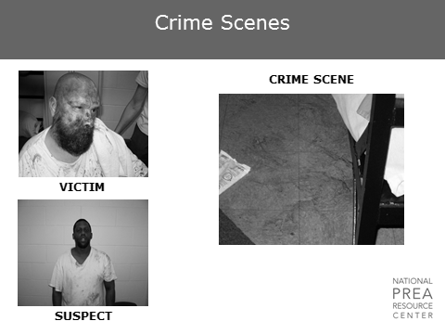  - Photograph or video the surrounding areas such as hallways, corridors, and adjoining rooms.  - Take full-length photographs of the victim and suspect, but do not have them remove any clothing to do so.  - If there are visible injuries on the victim and the victim agrees, take photographs of the injuries. Only medical staff should take photographs of areas that would require the victim to remove clothing or might be embarrassing.  - Use a measuring stick or sticker to show the size of injuries or bruises. Re-take the photos two or three days after the event to show the progression of the injuries. | Crime Scenes
1 min | Sources of DNA  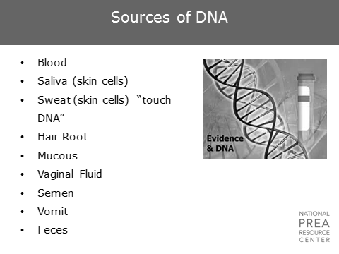  There are a variety of sources of DNA  - Blood, saliva, sweat  - Hair roots  - Mucous, vaginal fluid, skin  - Semen, vomit, feces.  These can be retrieved from either the alleged victim or the suspect or from their clothing and the surrounding area. | Sources of DNA
1 min | Physical Evidence to Collect  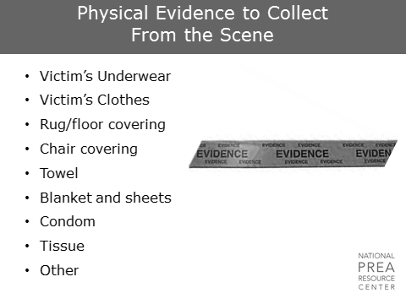  It is important to collect all materials from the scene that might contain that DNA  - Clothing, rugs  - Towels, sheets  - Tissues, etc.  Evidence collection should only be done by someone trained and familiar with proper collection techniques.  Usually, the state medical examiner or the prosecutor will have a detailed handbook concerning collection and proper handling of evidence. Other sources for forensic evidence collection can be found at the National Forensic Technology Center. | Physical Evidence to Collect
1 min | Sexual Assault Evidence Kit  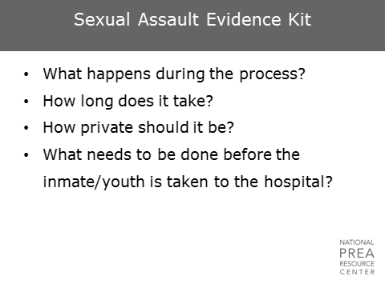  - The medical evidence collection and exam process takes a number of hours and should be conducted in a private place.  - The exam should be conducted by a Sexual Assault Nurse Examiner (SANE). Ideally, the SANE conducts the exam alone with the alleged victim. If security procedures do not allow this, ensure that the staff member present is of the same sex, and ensure that he/she understands the process and the need for privacy.  - The only responsibility that facility medical staff has before the forensic medical exam is treating any immediate medical needs. The facility should not take photographs of the victim as this will be done by the SANE. | Sexual Assault Evidence Kit  Trainer note – if including Module 5, delete or summarize these slides.
1 min | Physical Evidence SANE Will Collect  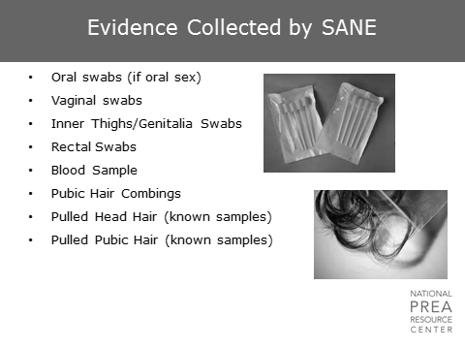  The SANE will  - Run through a full medical history with the victim and obtain a thorough understanding of all aspects of the assault.  - Take pictures of all injuries and areas of the victim touched by the assailant.  - Collect numerous samples from all areas that may contain DNA evidence, including the mouth, genitals, rectum, inner thighs, pubic hair, etc. | Physical Evidence SANE Will Collect  Do not include this slide if training Module 5.
1 min | Physical Evidence to Collect  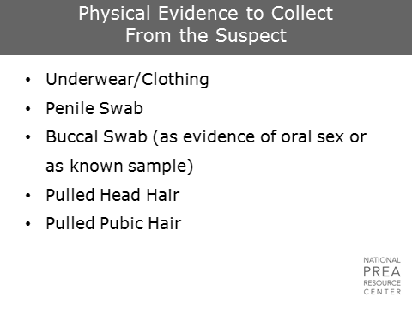  If there is an obvious suspect, he/she must go through a similar process to provide DNA for comparison against the samples collected from the victim. Any other evidence that may be on the suspect’s clothing or body is collected for consideration in the investigation. | Physical Evidence to Collect
3 min | Assessment of Forensic Exam  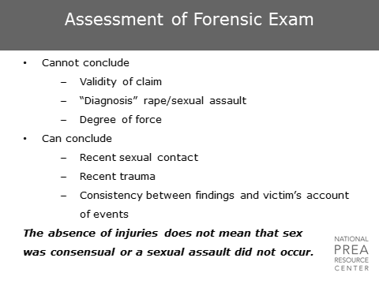  It is important for investigators to understand what the evidence collected from forensic medical exams can tell them. Forensic medical exam results will not provide investigators with clear “yes” or “no” answers in response to whether a sexual assault occurred. The exam  - Can tell you whether the victim experienced recent sexual contact or recent trauma.  - May or may not be able to provide DNA evidence showing whom the recent sexual contact was with.  - Cannot, by itself, prove the validity of a claim, and cannot always provide information regarding the degree of force used. The findings can be compared to the victim’s account of events to determine consistency.  Most importantly, however, investigators must understand that these exams are limited in their findings, and an absence of injuries or findings from the exam does not mean that the sex was consensual or that sexual abuse did not occur. | Assessment of Forensic Exam
3 min | Physical Evidence to Collect from the Scene  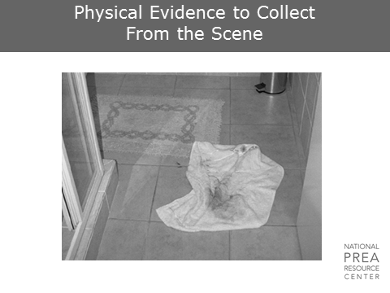 | Physical Evidence to Collect from the Scene  Ask: What would you collect here? What else could you do here?  Answer: Towel, Rug, trash can contents. Note blood on floor. Check the shower for evidence.
1 min | Processing the Crime Scene  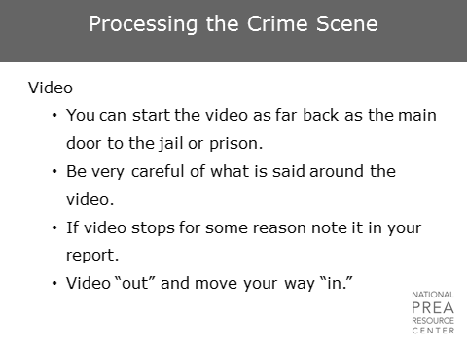  If you videotape the crime scene, which can be extremely useful, ensure you are careful while doing so.  - You can begin videotaping when you enter the facility, or you can wait until you enter the actual crime scene.  - Do not say anything on tape that you would not want played in a courtroom.  - If you stop the video, note it in the report.  The video is evidence. No one without a “need to know” should have access to it. | Processing the Crime Scene
1 min | Processing the Crime Scene  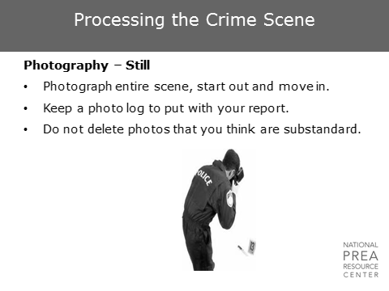  Photograph the entire crime scene. This should include  - A wide-shot photo or video of the crime scene as a whole  - Closer shots of sections and areas of relevance.  Ensure that only identified staff touch or handle any evidence.  Keep a list of each photo in order noting what each photo depicts, and secure the camera until the images are uploaded or printed to maintain the chain of custody. Document and mark each photo with the  - Date, place, time  - Who or what is in the photograph  - Who took the photograph?  Never delete images if using a digital camera. Re-take photos if necessary, and save both images. | Processing the Crime Scene
1 min | Processing the Crime Scene  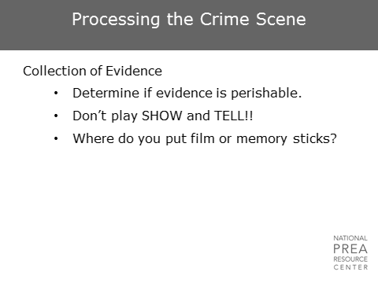  Bring containers for collecting evidence. If the evidence is perishable, ensure you package it properly. Take the evidence seriously – those who do not need to see it should not have access.  Secure the film and memory sticks. | Processing the Crime Scene
1 min | Processing the Crime Scene  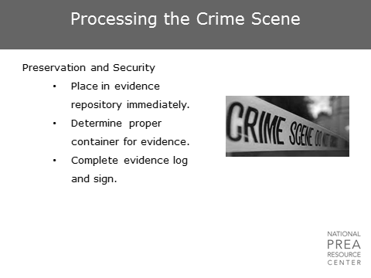  The evidence should be  - Properly transported or stored immediately  - Recorded in a detailed evidence log.  Determine and use the proper container and method for collecting each piece of evidence. Be prepared with the necessary tools – the materials and packaging must be sterilized and designed for evidence collection. | Processing the Crime Scene
1 min | What is wrong with this photo?  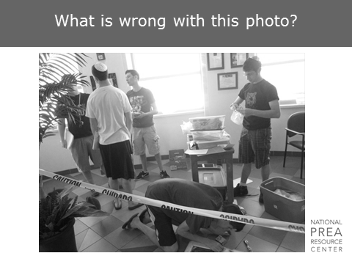 | What is wrong with this photo?  Ask: What is wrong with this photo?  Answer: There are too many people on the scene. People (often administrators) stop by crime scenes out of curiosity, or people may linger after completing their duties. Every person who steps into a crime scene – even the Warden – needs to sign in and out. If there are too many people stopping by, remind people that they may be called into court if the case goes to trial if their name is on the crime scene log.
1 min | Hair – Take it or leave it?  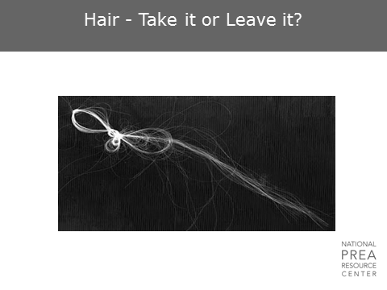  If the hair is attached or embedded in a moveable object, leave it intact and take the entire item.  If it is not firmly attached, collect it and place it in a paper bindle, clean envelope, or small plastic bag. | Hair – Take it or leave it?
1 min | What are we bagging?  How are we bagging it?  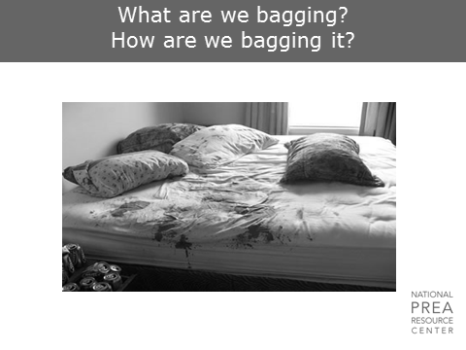 | What are we bagging?  How are we bagging it?  Ask: What are we bagging?  Answer: Pretty much everything: pillows and pillow cases, bedding, mattress. Note the dripping onto the floor – bag any rug or section of carpet there. Collect beer cans for possible saliva.  Ask: How are we bagging it?  Answer: Depends on whether the fluids are wet or dry. Use appropriately sized bags. Don’t combine pieces of evidence into a single bag. Ensure everything is appropriately tagged.
1 min | Evidence Handling  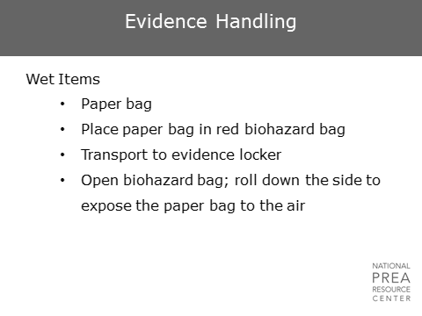  Place wet items in a paper bag or other appropriate container, and place that in a biohazard bag for transport. When it is placed in the evidence locker, open the biohazard bag and roll down the side to expose the paper bag to air. Do not use plastic containers to collect wet evidence.  If there are pooled bodily fluids such as blood, collect it in a sterile glass pipette and place it in a sterile glass tube. You can also use a glass microscope slide to scrape up the fluid and place that in a glass container. | Evidence Handling
1 min | Use of Luminal  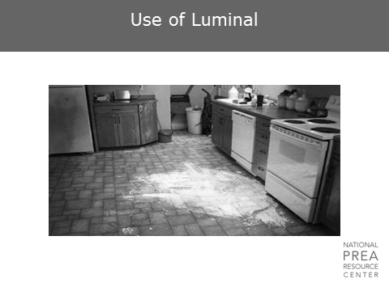 | Use of a Luminal  Ask: Who here has used luminal? What procedures are appropriate?
1 min | Evidence Handling  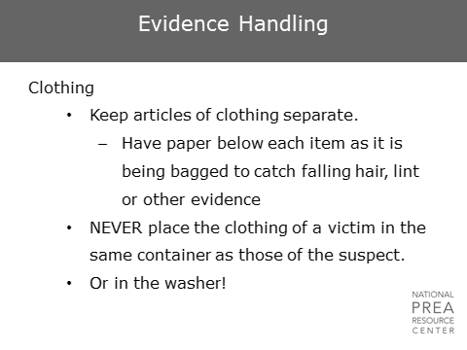  Never place items of clothing from the victim and the suspect together. Place each item of clothing collected in an appropriately sized paper bag. Plastic is sometimes acceptable, but remember that it can destroy potential evidence if there is any dampness to the clothes or linens.  When removing the clothing of a victim or suspect  - Have them stand on a large, sterile medical pad if available. A large clean sheet or piece of paper can also work.  - Gather all of the clothing together into the sheet or paper and package it all together. Note that this should typically be done by medical practitioners. | Evidence Handling
1 min | What would you take?  How would you take it?  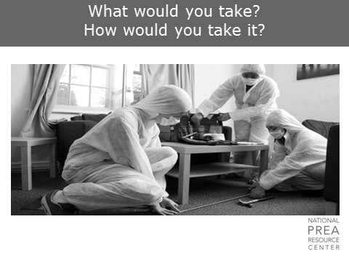 | What would you take? How would you take it?  Discuss in light of past slides and experiences in sexual abuse cases occurring in offices. Consider collecting: carpet, chair cushions or entire chair, checking tables and curtains, etc.
1 min | Evidence Handling  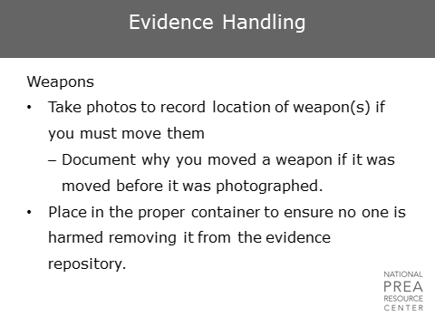  Photograph the placement of the weapon before you move it. If you have to move it, document why you moved it before it was photographed.  Ensure the weapon is placed in the container in such a way that no one will be harmed while removing it. | Evidence Handling
1 min | Evidence Handling  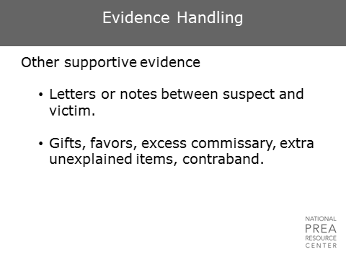  Ensure that all pieces of possible evidence are collected, including any letters, notes, or other exchanged items such as commissary or contraband. | Evidence Handling
1 min | Evidence  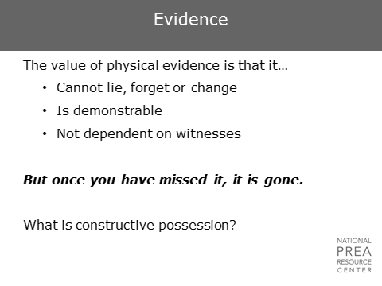  Can you prove  - That the evidence belongs to the person that your documentation says it belongs to and  - That the evidence got to where you found it by the process you articulate? Can you construct the history of the evidence?  For example, if you collect DNA evidence in the form of sperm on a cell floor, can you prove it is there as a result of a sexual abuse as reported, or does the suspect also live in the room? If yes, is there a possibility that the suspect ejaculated on the floor as a result of masturbation? | Evidence
3 min | Evidence  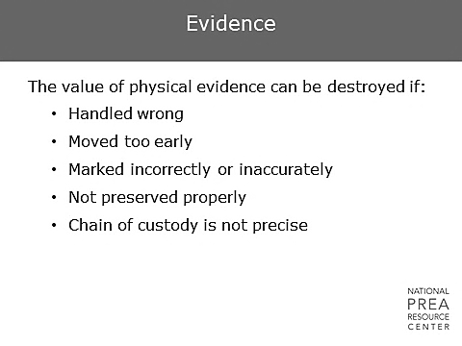  It is absolutely critical to maintain a detailed log of the chain of custody for each piece of evidence collected. An inability to demonstrate chain of custody renders that item of evidence useless for criminal proceedings.  Chain of custody should be demonstrated in writing with the following information for each piece of evidence  - When, where, and by whom it was collected and packaged.  - Each time the evidence changed hands. The log must show  - Who handed over the item  - To whom the item was given  - The date  - The time and place of the turnover  - The signature of both parties  - All evidence repositories must provide secured, documented supervision at all times. | Evidence
2 min | Crime Scene Mishaps  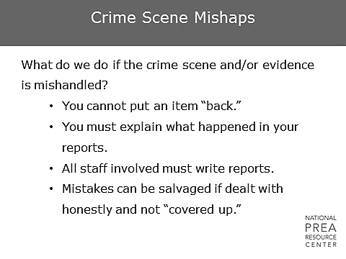  Don’t try to cover-up or avoid mentioning mistakes made when collecting evidence in your report. Any mishandling of evidence must be clearly explained in the reports of all individuals present. | Crime Scene Mishaps
5 min | Questions?

