Module 5: Role of Medical and Mental Health Practitioners in Investigations

Time: 3:15 p.m. – 4:45 p.m. (1 hour and 30 min)

Training Objectives:

- Understand the PREA standards applying to medical and mental health care practitioners in the investigative process
- Describe the steps of the forensic medical exam process
- Explain the role of victim advocates

Materials Needed:

- Easel pad and markers
- PowerPoint® player/machine (laptop computer and LCD projector)
- Screen or monitor
- Handout: United States Department of Justice National Standards to Prevent, Detect, and Respond to Prison Rape (2012). Note that both the Prison and Jails Standards and the Juvenile Standards are provided as handouts. Select the set of standards appropriate to the population of your agency.

This module was developed by Christine Kregg of Just Detention International and Charma Blount of the Texas Department of Criminal Justice in conjunction with The Moss Group, Inc.

Training Tips:
- The purpose of this module is to educate investigators on the role of medical and mental health staff in the investigative process, and encourage them to collaborate with the appropriate practitioners to enhance communication, victim outcomes, and the investigative process.
- Consider bringing someone from your medical or mental health department to co-present this module and speak to agency policy and practices in the areas discussed in this module. Additionally, the central portion of this module is an in-depth overview of the forensic medical exam process. Consider bringing in a Sexual Assault Nurse Examiner (SANE) or someone from your medical department who has been appropriately trained to present that section of the module.
- Be advised that this module may contain material that utilizes concepts and language that may be upsetting or difficult for some participants. This may include statements referring to genitalia, sexual harassment, sexual abuse, trauma, and suicide. Videos used may also contain profanity. Please review all materials prior to using to ensure they are appropriate for use in your agency and make substitutions where needed. You should also consider providing a general notice to participants at the beginning of each training session.
- Please note that this module was developed specifically for facilities that use the Adult Prisons and Jail or Juvenile PREA Standards. Facilities using the Community Confinement or Lockup standards should review all standard references to ensure that the content and language is appropriate for their facility type and inmate/resident population and adjust the material as needed to their specific circumstance.

Time | Lecture Notes | Teaching Tips
1 min | Medical and Mental Health Interventions  Why is this relevant to investigations? If victims don’t have medical/mental health care, they can’t cooperate in the investigation. Additionally, your knowledge of what types of care should be provided and your follow-up on this with the victim will build trust. |   Medical and Mental Health Interventions
1 min | Training Objectives  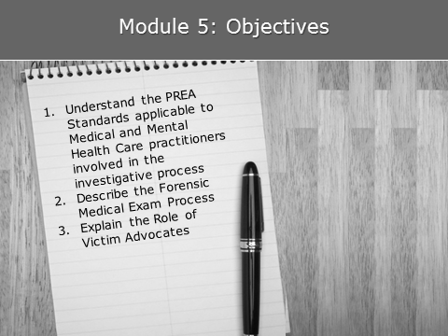 | Objectives    Provide participants with a full copy of the PREA standards appropriate to the population of their agency. State that you will only be going over select standards, but you encourage them to review the full set of standards at their convenience.  Note that this module does not address all the PREA Standards. It only addresses those standards addressing the role of medical and mental health staff in investigations.

5 min | Evidence Protocol and Forensic Exams  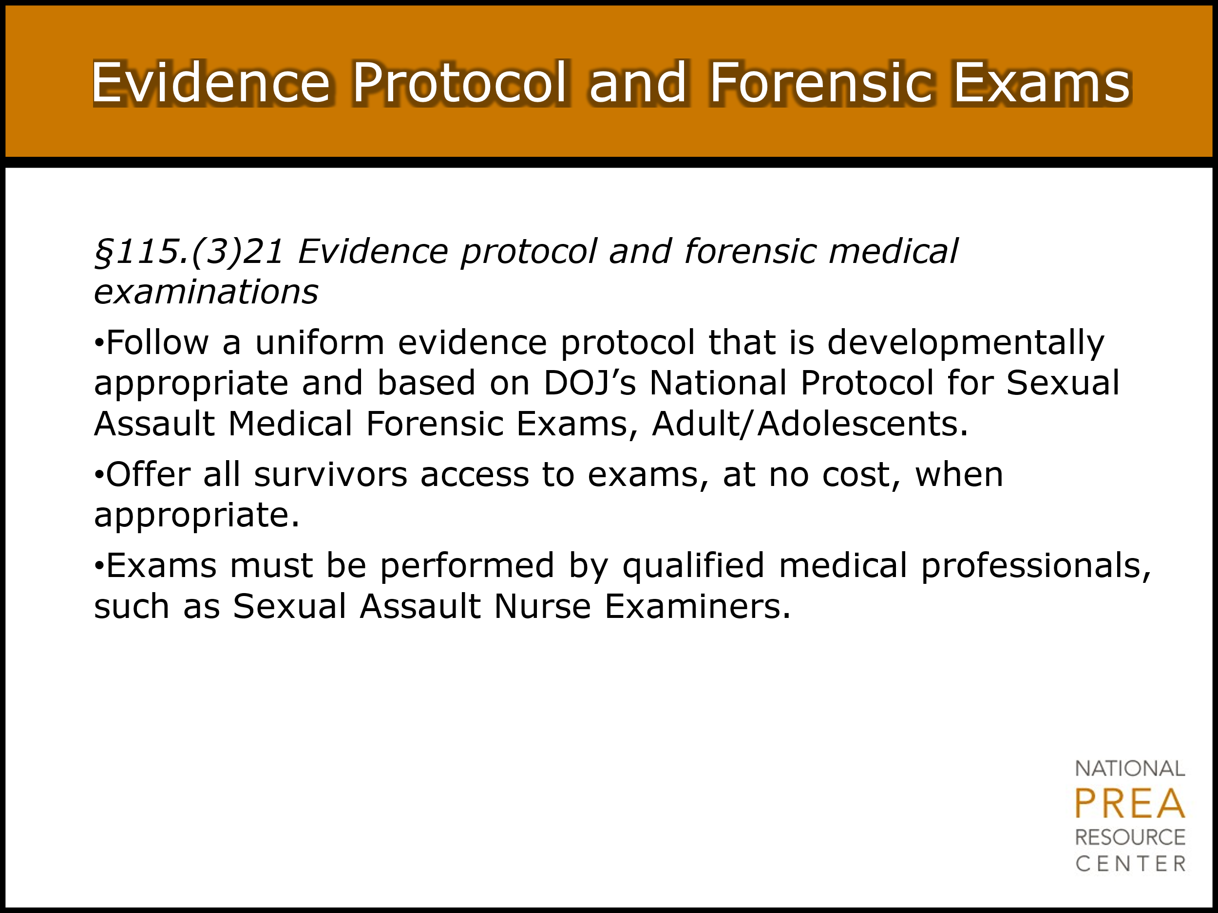  The PREA Standards require that investigations are conducted according to a uniform evidence protocol. The Standards recommend following the protocol in the U.S. Department of Justice’s Office on Violence Against Women publication, A National Protocol for Sexual Assault Medical Forensic Examinations, Adults/Adolescents.  The purpose behind standard 115.21 is  - To ensure all investigations are conducted using a consistent process, and  - To ensure the process is in line with best practice.  One element of the protocol that is required by the standards is the forensic medical exam. The standards require that all victims of sexual abuse be offered a forensic medical exam and that the exam be free of charge to the victim. Additionally, the standards require that the agency attempt to ensure that the exam be conducted by a Sexual Assault Nurse Examiner (SANE) or a Sexual Assault Forensic Examiner (SAFE) or, short of that, by other qualified medical practitioners. | Evidence Protocol and Forensic Exams  Emphasize that the victim receives these services at no cost, per best practice as recommended through the victim assistance community. Discuss if concerns are raised.  Refer to “National Protocol for Sexual Assault Medical Forensic Examinations Adults Adolescents” attachment.  Insert agency policy regarding provision of forensic medical exams.

4 min | Evidence Protocol and Forensic Exams – Access to Advocates  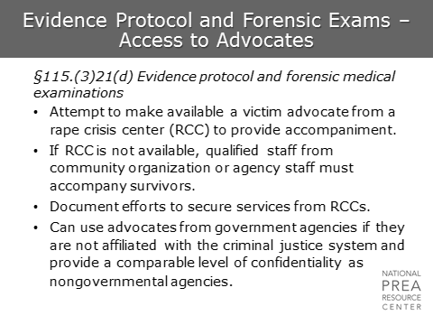  The standards also require that victim advocates from rape crisis centers be made available to victims, if possible.  Why do we need outside advocates? Outside advocates can be truly independent and impartial since their sole focus is on the well-being of the victim. As a result, they can develop a relationship with the victim that may allow them to provide support that the victim may otherwise be unable to access.  If you are unable to access a victim advocate from a Rape Crisis Center, be aware that there are agencies outside of Rape Crisis Centers that can provide victim advocates, including mental health service agencies, drug treatment agencies, and sexual health agencies. | Evidence Protocol and Forensic Exams  Insert agency policy regarding provisions of victim advocates and procedures for investigators to access victim advocates
1 min | Evidence Protocol and Forensic Exams – Access to Advocates  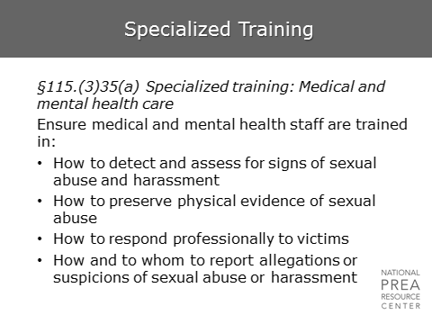  The victim advocate may accompany the victim through the entire investigative process, including the interviews. This module will discuss the role of the victim advocate and how their presence can benefit the investigator in more depth later in the module. | Evidence Protocol and Forensic Exams
1 min | Specialized Training  Just as investigators receive specialized training, so do medical/mental health care practitioners. Note that the training requirement is learning how to preserve, not collect, evidence. This is because, ideally, the agency practitioners will not be performing the forensic medical exam in which the evidence is actually conducted. | Specialized Training
1 min | Specialized Training, Cont.  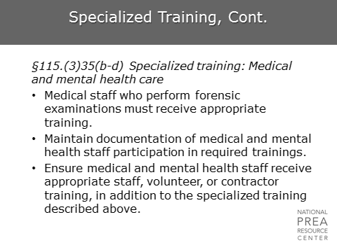  However, in the event that external SANEs or SAFEs are not available to perform this task, this standard also includes specialized training for conducting forensic medical exams. Best practice is to conduct the exam outside the agency. | Specialized Training, Cont.
3 min | Access to Outside Confidential Services  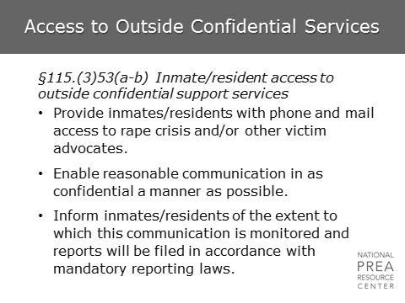  In addition to making victim advocates available to victims, the standards require outside confidential support services to be made available to all inmates/residents in a facility. | Access to Outside Confidential Services  Insert agency procedures to make access to outside confidential services available to inmates
1 min | Access to Outside  Confidential Services – Agreements  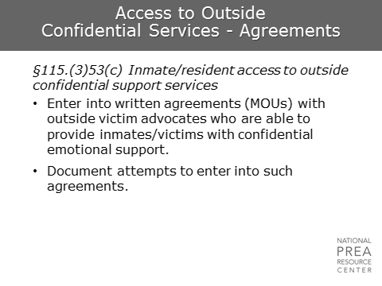  If an agency is unable to enter into an MOU with an agency to provide confidential support services, they have to demonstrate the attempt to do so. | Access to Outside  Confidential Services

5 min | Coordinated Response  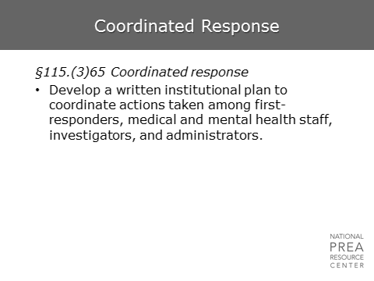  Facilities must ensure that a coordinated response procedure has been developed, which clearly defines the responsibilities of first responders, medical and mental health staff, investigators and administrators. Often, this may take the form of a SART (Sexual Assault Response Team). | Coordinated Response  Insert agency policy regarding sexual assault response team members and responsibilities.
1 min | Access to Emergency Medical and Mental Health Care  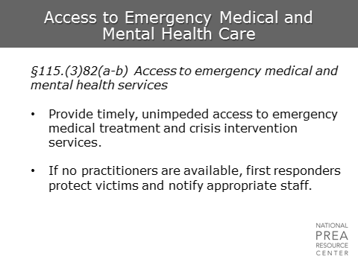  In particular, the first responder must ensure that these interventions are provided to victims. However, for investigators to know the services offered to victims following a report is important. Appropriate delivery of services will build trust between the victim and the agency, which may lead to more reporting and greater honesty in interviews. Similarly, informative answers to victim’s questions regarding emergency care will aid in relationship-building.

4 min | Access to Emergency Medical and Mental Health Care  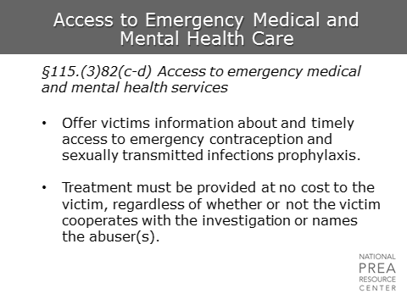  The standards require agencies to offer victims timely access to necessary medical services, including emergency contraception and sexually transmitted infections prophylaxis at no cost and regardless of whether the victim cooperates with the investigation or names his/her abuser. The timely element of this is crucial, especially for prophylaxis and other treatments that only work for a certain period of time. | Access to Emergency Medical and Mental Health Care  Insert agency policy regarding emergency medical services.
1 min | Access to Ongoing Medical and Mental Health Care  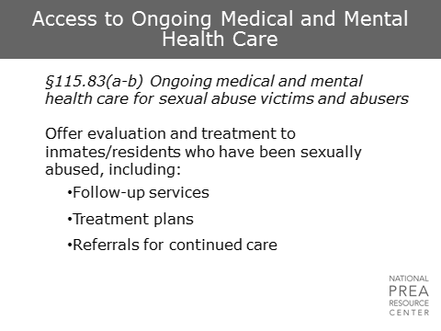  The standards also require agencies to provide ongoing care and referrals, if necessary. | Access to Ongoing Medical and Mental Health Care

1 min | Access to Ongoing Medical and Mental Health Care, Cont.  Ensuring that victims receive timely access to appropriate healthcare can be extremely important in the context of sexually transmitted infections and pregnancy. | Access to Ongoing Medical and Mental Health Care, Cont.
1 min | Access to Ongoing Medical and Mental Health Care, Cont.  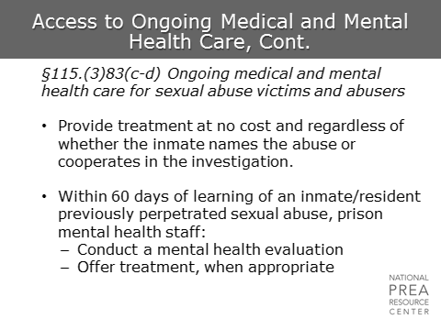  In the case of prisons and juvenile facilities, this ongoing care also includes some requirements for providing mental health treatment for abusers. Since the investigator will have contact with the victim and the perpetrator (if identified), the investigator should be sure to make the appropriate notifications to the persons within the agency who are responsible for medical and mental health interventions for both parties. | Access to Ongoing Medical and Mental Health Care, Cont.

1 min | Interpreting the Medical and Mental Health Standards  Corrections must offer victims of sexual abuse:  - Hospital accompaniment by an advocate  - Emergency and ongoing medical and mental health care  - Forensic evidence collection, as appropriate  - Preventive measures such as pregnancy and HIV/AIDS tests and prophylaxis | Interpreting the Medical and Mental Health Standards
1 min | Interpreting the Victim Services Standards  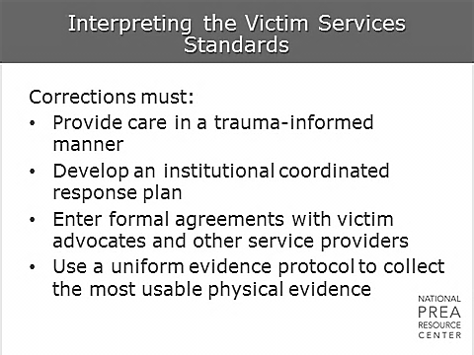  Corrections must:  - Provide care in a trauma-informed manner  - Develop an institutional coordinated response plan  - Enter formal agreements with victim advocates and other service providers  - Use a uniform evidence protocol to collect the most usable physical evidence | Interpreting the Victim Services Standards
1 min | The Forensic Medical Examination  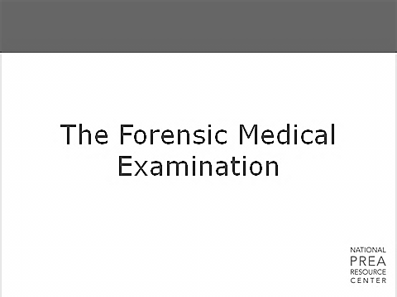  It is important for investigators to understand the process of the forensic medical examination, both to ensure that the investigator knows how to access and interpret any collected evidence, and to ensure that any conversation the investigator has with the victim prior to or following the exam is informed by the process. Many victims consider the process of the forensic medical exam to be extremely traumatizing and violating. | The Forensic Medical Examination
2 min | Sexual Assault Nurse Examiner  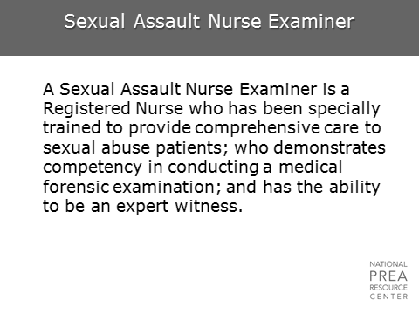  A Sexual Assault Nurse Examiner (SANE) is a registered nurse who has been specially trained to provide comprehensive care to sexual abuse patients; who demonstrates competency in conducting a medical forensic examination; and has the ability to be an expert witness.  “Forensic Nurses specialize in caring for victims and perpetrators of violence. They care for the physical, psychological, and social trauma that occurs in patients who have been sexually abused. Forensic nurses also have a specialized knowledge of the legal system and collect evidence, provide medical testimony in court, and provide consultation to legal authorities.”  IAFN – Texas Chapter | Sexual Assault Nurse Examiner
1 min | Forensic Medical Examination  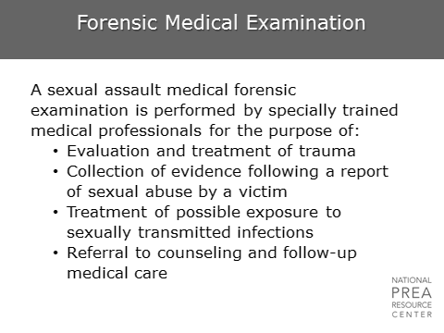  A forensic medical examination is a medico-legal physical examination to retrieve evidence to support an allegation of sexual abuse for future prosecution. The examination, collection of evidence, and documentation of injury may be necessary either to substantiate an allegation or to help strengthen a case. The goal is to provide interventions that improve the physical and mental health and well-being of sexual abuse survivors – by decreasing the acute and long term effects of the abuse and helping to return the victim to their previous functioning state. | Forensic Medical Examination

1 min | Medical Examination for Sexual Abuse Victim  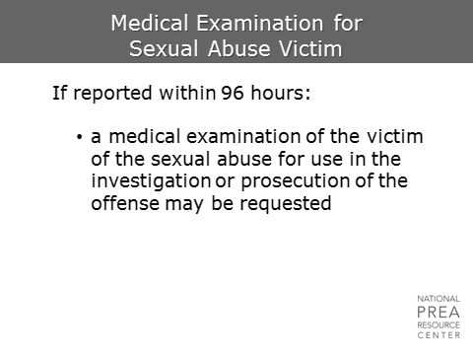  A victim always has the choice to not undergo an exam. | Medical Examination for Sexual Assault Victim  Check your jurisdiction to establish the correct time frame for this slide. Some jurisdictions limit the timeframe to 72 hours; others have extended the timeline to 120 hours or longer.
1 min | Dual Purpose of the Forensic Exam  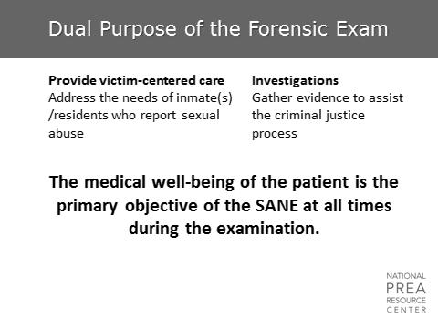  The forensic medical exam has two purposes. The primary purpose is to address the medical needs of the victim. The secondary purpose is to assist in investigating the abuse by collecting any evidence that may exist. | Dual Purpose of the Forensic Exam

1 min | Restraints should not restrict!  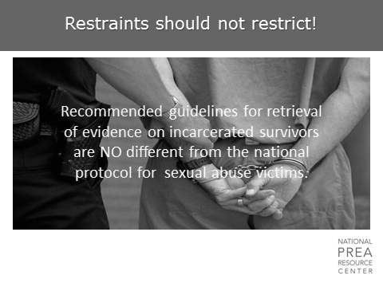  The Prison Rape Elimination Act of 2003 recommends that medical services provided to incarcerated victims should be no less than the care received by a victim in any health care facility/setting, and PREA standard 115.83 (c) requires provision of community level of care. In a situation of sexual abuse, a victim’s status as an inmate or resident should not detrimentally affect the care they receive. | Restraints should not restrict
1 min | Victim Adaptations  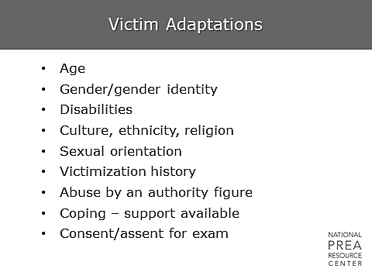  The examination is adapted as necessary to address the needs and circumstances of the victim – physical and psychological.  It is important to avoid making assumptions about the victim and the abuse. Discussions with the victim are framed in such a way that does not assume they are of a specific background. Medical practitioners try to understand their circumstances and tailor the exam process to address their needs and concerns. If possible, this should be true of medical treatment within the victim’s facility as well as at external hospitals or clinics. | Victim Adaptations
1 min | What does a sexual assault forensic medical examination entail?  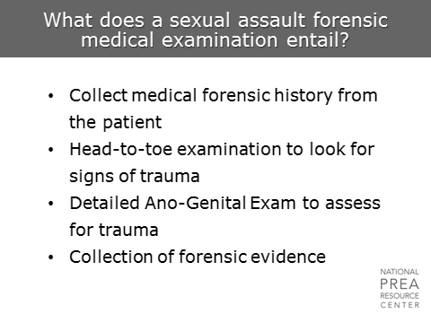  It is important to prepare the victim prior to beginning any procedure. This also aids in restoring the victim’s physiological and emotional sense of predictability and control over what’s happening.  Once consent is obtained from the patient, a medical history is taken to determine injuries and appropriate medical treatment. The next step is a head-to-toe examination, including the anogenital area, in order for the SANE to document trauma to any part of the body. Lastly, a collection of forensic evidence is done. | What does a sexual assault forensic medical examination entail?
5 min | First Steps  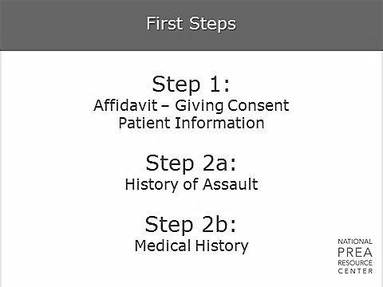  Once it has been decided that a sexual assault kit will be utilized, the seals are broken, and the kit opened. This is the first step in the chain-of-custody.  Step 1: Giving consent. The victim (or guardian) MUST give consent for this examination. In extenuating circumstances where consent cannot be obtained (such unconsciousness or impairment) a next-of-kin may be contacted for consent (with witnesses) and/or a court-order may be necessary.  Step 2a: History of assault. A more detailed description of the assault. The “who, what, when, where, how” of forensics. Was the perpetrator known? Were there threats? Did the victim fight? Did ejaculation occur? What positions was the victim forced into? Is there any area where biological evidence may be found?  Edmond Locards’ Principle of forensics states that: “With contact between two items, there will be an exchange.” That’s what the forensic exam is after – the exchange…the evidence. Our forensic field: the victims’ body.  Step 2b: A complete medical history of the victim. This includes: past surgeries/injuries; pregnancies; and any existing conditions or communicable diseases. | First Steps
2 min | Step 3: Clothing Collection  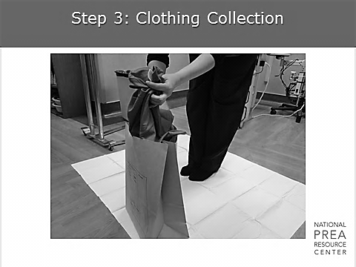  A head-to-toe assessment is completed on all exposed areas of the body to get as much evidence as possible prior to having the victim disrobe. All injuries are documented:  - Type (such as bruises, lacerations/cuts, abrasions, scratches, etc.)  - Location  - Size (measurement of injury in length & width) and color  - A collection of any foreign debris/object not normally found on the body (such as: grass, twigs, sand, dirt)  Once the head-to-toe assessment is completed and any evidence found has been collected:  - The victim is asked to stand on a paper sheet provided in the kit and to disrobe.  - Clothing is removed and placed upon the paper sheet.  - Once undressed, the victim is provided a sheet and assisted onto the exam table and/or chair.  - The clothing is examined for any tears, stains, or blood. If any are found, they are marked appropriately.  - Each article is bagged separately in paper bags and labeled with identifiers, along with the date and time of examination/collection.  Facilities should be aware that the victim’s clothing will be collected as evidence, and bring a change of clothing with the victim to replace the collected clothing. | Step 3
1 min | Step 4: Debris Collection  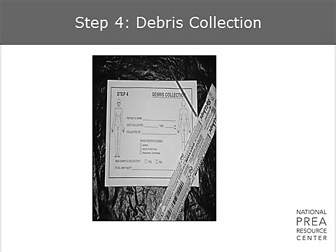  Once the victim has disrobed, any foreign objects that are found on the body during the examination will be placed in this envelope. If fingernail scrapings and clippings are obtained, each hand is done separately and labeled accordingly. | Step 4
1 min | Step 5: Oral Swabs & Smears  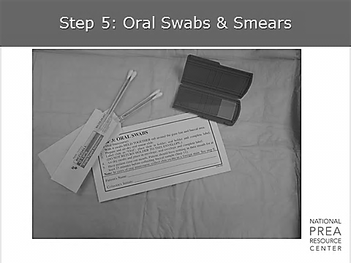  After oral inspection and documentation of injuries, swabs are obtained for DNA and ACP (prostatic acid phosphatase, which is found naturally in both men and women – with higher concentration found in semen). Swabs are done by briskly rubbing the inside of both cheeks (buccal area) for several seconds. Then a smear is made on the glass slide for microscopic examination. Oral swabs can be just as important as vaginal or rectal swabs. | Step 5
1 min | Step 6A: Vaginal Swabs & Smears  Step 6B: Penile Swabs and Smears  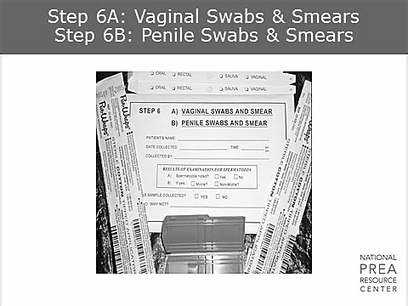  A detailed genital trauma assessment is performed. Inspection of the genitalia prior to collection of evidence is of utmost importance in order to note any injuries and to document all findings on the appropriate diagram.  For the male victim, the presence of saliva on the penis could indicate that oral-genital contact was made; feces or lubricant (such as saliva, grease, oil, etc.) may be found if rectal penetration occurred. | Step 6
1 min | Step 7: Rectal Swab & Smear  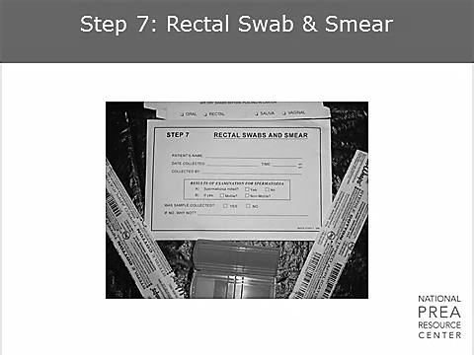  Any and all injuries are noted. Any tears, bruising, etc., color, measurement in centimeters, and location are documented. Swabs are obtained from around and in the anal opening, and a smear is made on the glass slide. | Step 7
1 min | Step 8: Head Hair Combings    During sexual abuse, hairs may be transferred from one individual to the person or clothing of another. These hairs can be microscopically compared to known hair samples from both the victim and suspect to determine the origin.  Head and pubic hair are the only hairs on the body that have enough individual characteristics for analysis. Delaying the collection of hair samples of the victim may adversely affect comparisons. | Step 8
1 min | Step 9: Pulled Head Hairs    Although DNA is much more reliable from good buccal swabs, pulled hair is still recommended for hair comparisons. Cuttings of hair without the root are of little forensic use. At this time forensic examiners typically comb for foreign hairs and pull known hairs from the victim to provide the best samples for comparative studies. | Step 9
1 min | Step 10: Pubic Hair Combings  Step 11: Pulled Pubic Hair    Biological evidence (such as: blood, semen, saliva) may be found in the matted hair. | Step 10, Step 11

1 min | Step 12: Blood Sample  Step 13: Saliva Sample  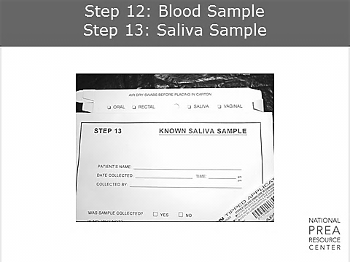  Saliva can also be used for ABO blood typing of the attacker. About 80% of individuals can be genetically typed from this marker. | Step 12, Step 13
1 min | Final Steps  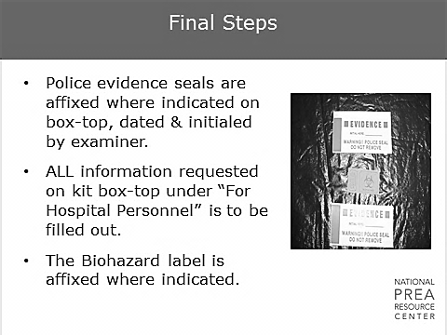  After ensuring that all envelopes, boxes, slides, blood tubes, paper bags, etc. are properly labeled and tape securely, the evidence is placed into the box and the box is sealed. Once sealed, it cannot be reopened.  Tampering with Evidence is a felony! | Final Steps

2 min | Documentation  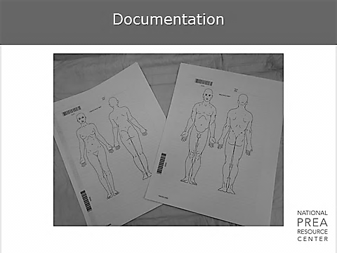  This page includes the male and female anatomy and all injuries should be documented on the appropriate chart. This is the victim’s information sheet.  The following are documented on this sheet:  - Medications and/or treatment that were given and/or ordered  - Tests that were performed, such as lab work and specimen collection for STIs  - Contact information for follow-up care, including the victim’s practitioner and mental health services provider | Documentation
1 min | Remember!  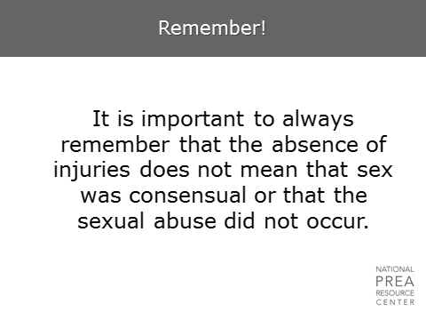  It is important to always remember that the absence of injuries does not mean that sex was consensual or that the sexual abuse did not occur.  The presence or absence of physical evidence does not prove whether a person has been sexually abused. Rather, the examination may provide supportive evidence to be used during legal proceedings. Documentation is a form of communication to other professionals working on the case. In a case hearing, one must be able to define every word that is documented! | Remember!
3 min | Access to Victim Advocates  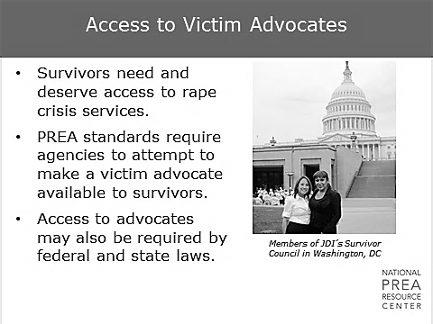  Why are victim advocates necessary? Sexual abuse in custody takes a considerable toll on survivors, their loved ones, detention facilities, and the community.  Inmate/resident survivors need and deserve rape crisis advocacy services, and most practitioners are not trained in rape trauma services, including trauma and rape crisis counseling. Additionally, some states require these services by law. | Access to Victim Advocates
1 min | The Rape Crisis Model  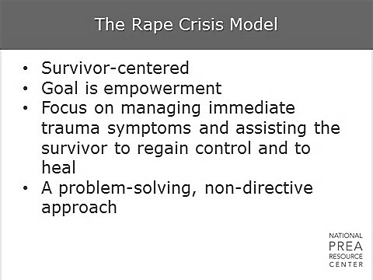  - Survivor-centered  - Goal is empowerment  - Focus on managing immediate trauma symptoms and assisting the survivor to regain control and to heal  - A problem-solving, non-directive approach  This model has shown to be effective for all survivors. | The Rape Crisis Model
1 min | The Role of the Victim Advocate  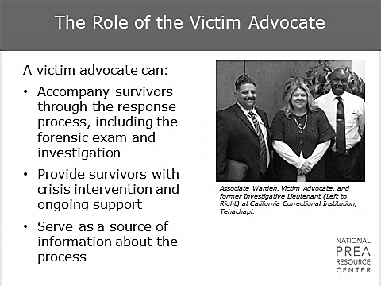  What is the role of victim advocates? Support. They can assist in getting consent and providing explanations. They can be staff or volunteers and may or may not be on-call all the time. Either way, they go through extensive training and are certified. | The Role of the Victim Advocate
5 min | Unique Role of the Victim Advocate  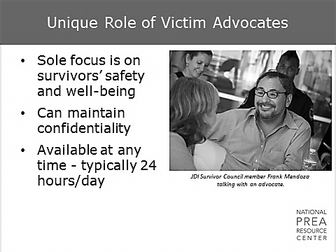  The victim advocate is unique in that their sole focus is on the safety and well-being of the victim. As a result, they can maintain confidentiality and be available to the victim throughout the day. | Unique Role of Victim Advocates  Ask the class to do an exercise with the intention of shocking participants rather than actually having them perform the exercise. Ask them to write down all the details of their last sexual encounter, and then pass it to their neighbor.  Emphasize that we’re asking survivors to do this multiple times, and their last sexual encounter was painful and unwanted.
1 min | Rape Crisis Model  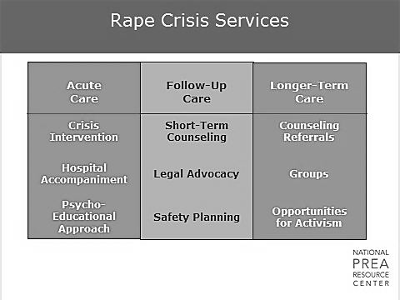  Rape crisis services fall into one of three categories: acute care, follow-up care, and longer-term care. Your interactions with the victim advocate will be during the acute and follow-up care stages. | Rape Crisis Services
1 min | Role of the Advocate During the Forensic Exam  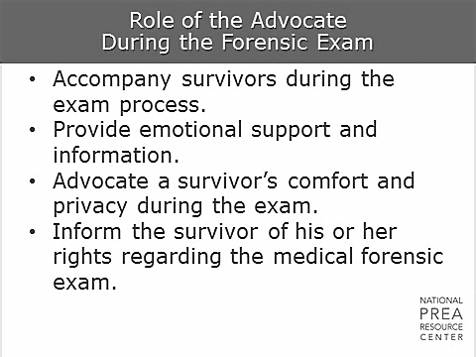  A victim advocate is supposed to be both informed and open-minded. They align themselves with the survivors and inform them of their rights.  Additionally, they will negotiate the survivors’ privacy and comfort during interviews and exams.  Finally, they will prepare the survivors to return to custody. | Role of the Advocate During the Forensic Exam
5 min | Role of the Advocate in Investigative Interviews  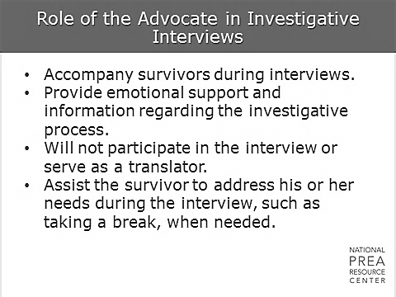  The role of the advocate during interviews is to provide support and information. The advocate will not participate in the interview unless specifically asked to do so, and will not serve as a translator. He/she will be solely focused on the needs of the victim.  Investigators should view victim advocates as partners. Victims are more likely to cooperate and to fully and honestly discuss the abuse if they are supported and as comfortable as possible. The victim advocate will provide the support and work to enhance the victim’s comfort so the investigator can focus on his/her job.  What are the strengths and challenges of working with a victim advocate during an investigation? | Role of the Advocate in Investigative Interviews  Discuss.  You may find there is some resistance to an “outside” person.

1 min | Role of the Advocate in Providing Ongoing Care  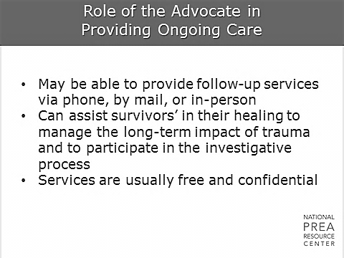  Victim advocates will remain in contact with the victim to assist in managing the long-term impact of trauma and to allow the victim to participate more fully in the investigative process. | Role of the Advocate in  Providing Ongoing Care
5 min | Victim Advocates and Confidentiality  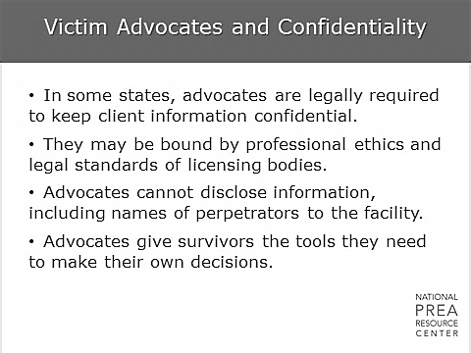  States vary in the legal requirements that exist around victim advocates, but many have specific educational requirements. In general, though, do not ask advocates to disclose information from their conversations with victims. | Victim Advocates and Confidentiality  Insert information on agency victim advocate role and services here.

5 min | The Benefits of Advocates  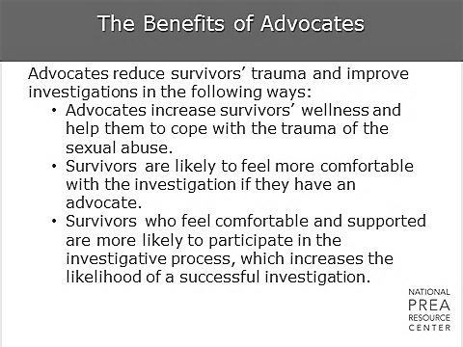  To reiterate, investigators should view victim advocates as potential partners who can benefit the investigative process and make the investigator’s job easier. | The Benefits of Advocates
 | Questions?

