Module 3: Investigations and Agency Culture

Time: 12:45 p.m. – 1:45 p.m. (1 hour)

Training Objectives:
- Explain how agency and facility culture impacts inmate/resident reporting and sexual safety.
- Describe how agency and facility culture impacts investigations and is impacted by investigations.
- Provide strategies for enhancing a culture of safety.

Materials Needed:

1. Easel pad and markers
2. PowerPoint® player/machine (laptop computer and LCD projector)
3. Screen or monitor

Teaching Tips:
- This module is intended to help investigators understand the link between successful investigations and the overall culture of the agency. The PREA Standards do not directly address culture. However, the Executive Summary to the United States Department of Justice National Standards to Prevent, Detect, and Respond to Prison Rape offers an important discussion of the critical role of leadership is creating a healthy culture. The Standards contain specific requirements for investigations that are best met when the agency’s culture is supportive of the investigative process. Refer to the “PREA Final Rule” attachment
- This module is primarily targeted to facility investigators. If training law enforcement, we recommend highlighting characteristics of correctional culture. Examples of cultural issues impacting investigations by outside law enforcement may include:
  - The potential for a high degree of contamination of evidence through multiple interviews.
  - Challenges in protecting crime scenes.
  - The high level of mistrust within the inmate/resident population.
  - The multiple and complicated relationships among staff and among inmates/residents.
  - The unique nature of sexual abuse in corrections. Victims of sexual abuse in corrections may experience repetitive assaults by multiple assailants over a period of time, and they are confined to the location of the abuse. They

cannot escape the environment of people that caused them harm. This level of trauma is more debilitating and can lead to severe and chronic Post
Traumatic Stress Disorder. The sexual abuse can also impact the victim’s social status and safety within the facility and may impact the victim’s trust in the system as a whole, which may delay or inhibit reporting.
- It is important to continually emphasize how culture can influence the investigative process and how the PREA Standards support creating and maintaining a healthy culture.
- This module includes a number of points where the trainer is instructed to discuss a question or statement with the audience. Emphasize throughout the training that participants should discuss what they believe most staff or offenders in the agency think. As a trainer, make use of the following exercises throughout this module to keep the class engaged:
  - Class-wide discussion: Ask the class as a whole and invite individuals to speak up.
  - Paired discussion: Ask the class to split into pairs and have the pairs discuss the question briefly before sharing with the class.
  - Group discussion: Ask the class to split into groups of four or five and discuss the question for five or ten minutes. Have the groups present their conclusions.
In the agenda provided, this module is one hour long. However, a trainer could extend the module to one hour and 30 minutes if he or she decided to further emphasize the discussions within the module.
- Be advised that this module may contain material that utilizes concepts and language that may be upsetting or difficult for some participants. This may include statements referring to genitalia, sexual harassment, sexual abuse, trauma, and suicide. Videos used may also contain profanity. Please review all materials prior to using to ensure they are appropriate for use in your agency and make substitutions where needed. You should also consider providing a general notice to participants at the beginning of each training session.
- Please note that this module was developed specifically for facilities that use the Adult Prisons and Jail or Juvenile PREA Standards. Facilities using the Community Confinement or Lockup standards should review all standard references to ensure that the content and language is appropriate for their facility type and inmate/resident population and adjust the material as needed to their specific circumstance.

Time | Lecture Notes | Teaching Tips
 | Agency Culture |   Agency Culture
1 min | Module 3: Objectives  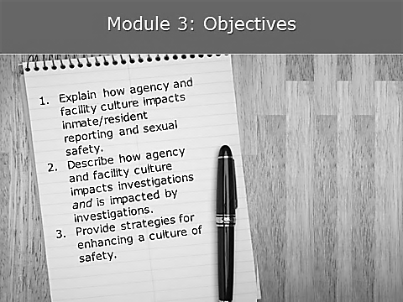 | Objectives
2 min | Definition of Agency Culture  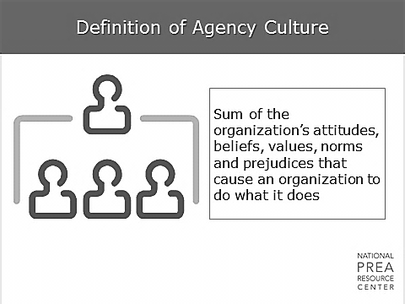  What is culture? The National Institute of Corrections defines culture as the informal beliefs, attitudes, and norms of the people within an organization. Although an agency or facility’s culture is not something that is easily identified, it has an enormous impact on the success of initiatives. Agency and facility leadership determine policy and official procedures, but it is the culture of a workplace that determines whether staff buys into the philosophy and follows the spirit and the letter of the policies in place. | Definition of Agency Culture
4 min | Components of Agency Culture  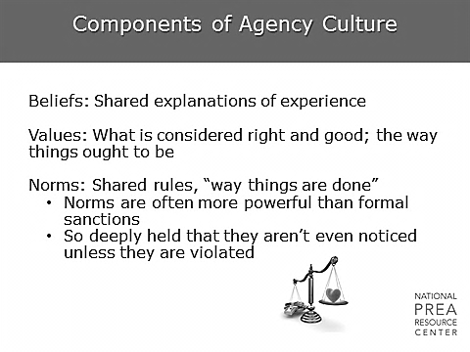  What makes up an agency’s culture?  - Beliefs. For example, the belief that you can’t be promoted unless you attend the boss’ Christmas party, tell dirty limericks or jokes, hunt or play golf, or belong to the same social club as the boss.  - Agency values. Zero tolerance for staff sexual misconduct is an agency value. The values in the correctional world are changing. For example, it is now common for women to work in male facilities. Not too long ago, this was not the case. Similarly, inmates/residents with mental health challenges are seen as needing treatment as opposed to just “crazy.”  - Agency norms. An example of an agency norm is that staff doesn’t volunteer for assignments. Another agency norm could be a code of silence – staff and/or inmates/residents won’t “snitch” on each other. Another norm could be that staff doesn’t socialize with people outside of the agency.  There are both formal and informal norms.  - One informal norm might be “staff is always right until proven wrong. Offenders always lie.”  - Another might be “forget everything you learned at the Academy. This is how it is done here.” If formal and informal norms conflict, people may receive mixed messages.  - Does policy say one thing, but informal norms dictate another? All agencies run into this problem. For example, does policy allow staff to touch an offender? Policy is often quite rigid, but informal norms may allow for more flexibility – for example, what if an offender’s mother just died or the offender just graduated from a program?  - Would informal norms sometimes grant permission for staff to give an offender/resident a handshake, pat on the back or even a hug in these situations? | Components of Agency Culture  Ask: What does the class think influences this agency culture?  Ask: What is your agency “touch” policy?
1 min | Objective investigations support the administration’s value of zero tolerance while having a positive impact on culture  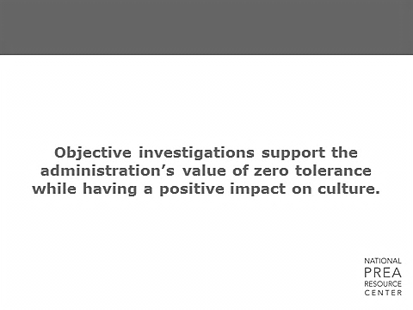  What does culture depend on? Cultures adapt from the top – so the top needs to model the behavior they want to have in their staff. If the top doesn’t communicate, the lack of transparency leads to distrust. If staff does not trust administration, staff will not cooperate with investigations and will often not support official policy. | Discuss with the class. Why is this important? What are the ways the investigative process improves or damages a positive culture?
4 min | Influences on Agency Culture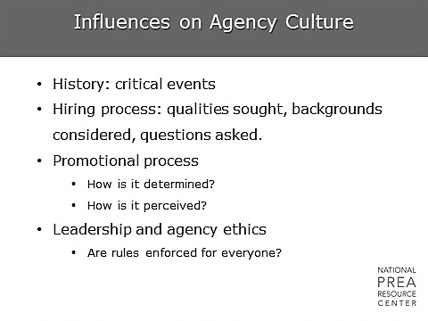  Culture is influenced by major events in the history of the agency. Our agency’s culture is particularly influenced by…  Culture is influenced by staff perception of the hiring process.  - Is staff promoted based on experience and qualifications?  - Is it based on who you know?  - Does staff believe that more recent hires were hired based on different qualifications than hires from years ago?  - Do staff talk about who gets certain jobs based on their relationship with someone?  - Are relationships (marriages, immediate family relationships, friendships) common among staff in your agency’s facilities?  - Are these relationships seen as influential to the hiring or promotional process?  Do staff perceive there to be favoritism or inequality in rules enforcement? | Influences on Agency Culture  Insert historical events significant to your agency, e.g. major lawsuit, leadership change, etc.  Ask participants what other events they believe have influenced the agency’s culture.  Discuss.
1 min | Influences on Agency Culture  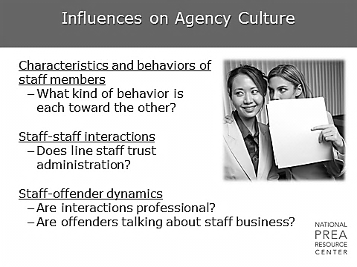  - Are staff relations respectful and honest? Are they team focused?  - Are they gossipy? Back biting? Sexual?  - Is there dating in the workplace?  How does this impact investigations? | Influences on Agency Culture  Discuss.  Some possible answers are: Culture can impact staff’s perception of whether they can trust agency processes, and whether the agency, their fellow staff, and leadership have their best interests in mind. Investigators should be aware, to the extent possible, of the cultural undercurrents in a facility so as to better understand the information they gather and the context within which the alleged incident occurred.
1 min | Staff believe that administration practice follows policy  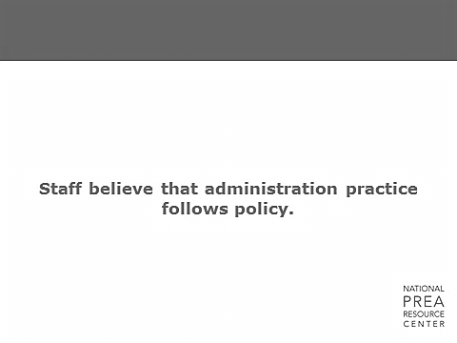  Staff members’ decisions on whether or not to follow policy or how to follow policy depends a lot on whether they perceive their facility or agency administration to be following policy. | Discuss. Why is this important? What is their impression within your agency?
1 min | Influences on Agency Culture  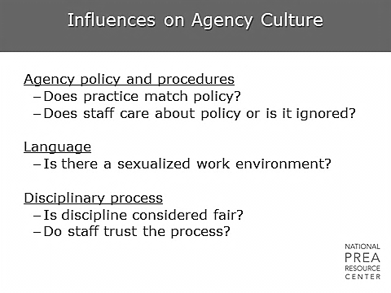  What is a sexualized work environment? It’s an environment where sex permeates everything – jokes, appearances, relationships between staff. | Influences on Agency Culture
1 min | Sexualized Work Environment  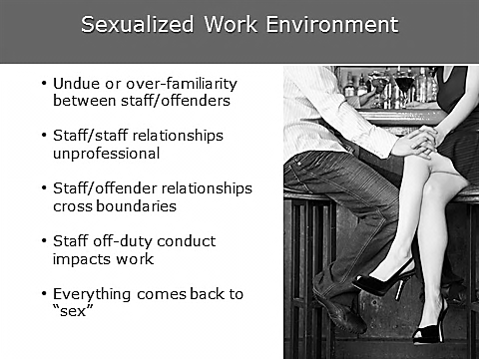  Does this agency have a sexualized work environment? Do certain facilities?  - When a work environment is sexualized – such as between staff and staff – it implicitly gives offenders permission to act similarly.  - When there are problems among the staff in any form, it can ripple down to the offenders. Offenders watch everything we do.  - This sexualization of an environment can shift the cultural norms. If sexual harassment is perceived as socially acceptable, the risk of sexual abuse will increase.  As an investigator, keep an eye out for signs of a sexualized work environment and be prepared to bring that information to the appropriate person if you think the environment could decrease sexual safety. | Sexualized Work Environment  Discuss. Why is this important?
1 min | In my facility, romantic relationships among staff are…  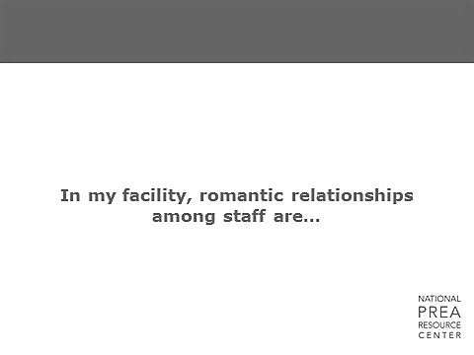  Common? Infrequent? Ubiquitous?  - Romantic relationships among staff create a sexualized work environment, especially if those staff members don’t leave their relationship at home. Additionally, they can lead to tension when the relationship runs into trouble.  - Offenders can take advantage of these relationships, and the environment they create can decrease sexual safety.  - There isn’t any way to control relationships between staff, and we don’t necessarily want to, but it’s important to know the risks they can create. | Discuss. Why is this important? What is their impression within your agency?
1 min | In my facility, staff discuss personal issues in front of offenders  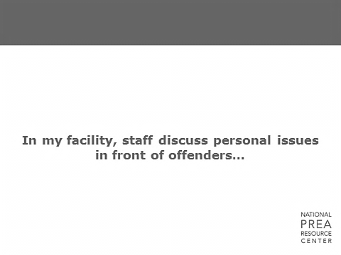  - Frequently? Sometimes? Never?  - Why is this worthy of conversation? Will the offenders pay attention to those personal issues being discussed? How will that impact the professional boundaries of staff? | Discuss. Why is this important? What is their impression within your agency?
1 min | Code of Silence  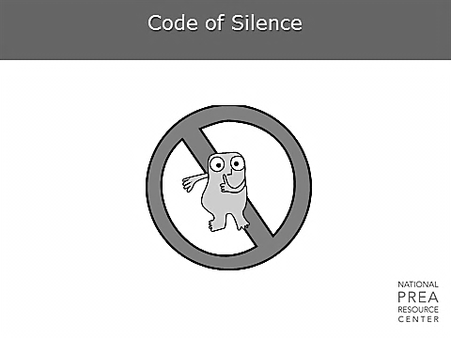  Who has heard of the term code of silence? What is it? | Code of Silence
1 min | Code of Silence  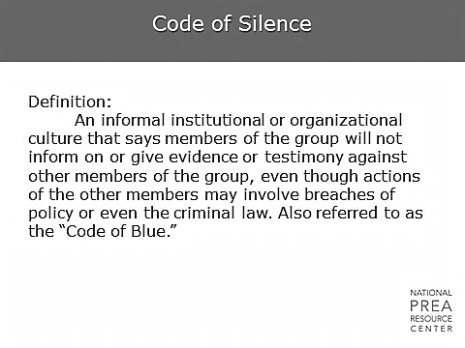  Definition:  An informal institutional or organizational culture that says members of the group will not inform on or give evidence or testimony against other members of the group, even though actions of the other members may involve breaches of policy or even the criminal law. Also referred to as the “Code of Blue.” | Code of Silence  Discuss. Is this accurate? Why might a code of silence exist? Possible answers are:  - It’s not my business (or my job!)  - Let everyone worry about themselves  - I don’t want to get involved  - People will think I’m a rat  - I will face serious consequences with my peers  - It will put me in jeopardy
2 min | Code of Silence  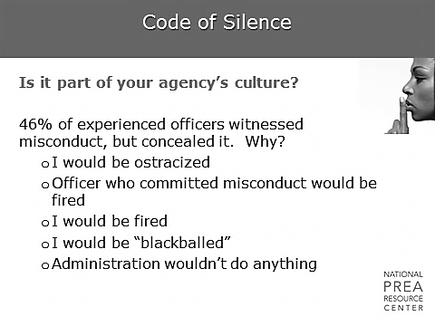  - Is there a pervasive attitude in your organization that no matter what the allegation, another staff member must not report misconduct by other staff?  - Does staff believe that it is worse to tell on someone than it is to demand professionalism within the agency?  - What about offenders? Is there an understanding among the offender population that reporting to staff will result in retaliation or repercussions from other offenders?  This study of the code of silence by Dr. Neal Trauma of the National Institute of Ethics provides some valuable insight into the pervasive and destructive nature of the issue. These elements are most relevant to correctional agencies as investigators seek to assess their agency’s culture and address the highly explosive subject of allegations of staff sexual misconduct with inmates. They are also particularly relevant to investigators as they investigate allegations of sexual abuse and sexual harassment between offenders and between staff and offenders. | Code of Silence  Discuss.  Discuss.
1 min | In my facility, a code of silence is…  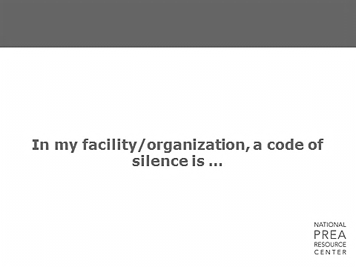  A major concern? Somewhat present? Nonexistent? | Discuss. Why is this important? What is their impression within your agency?
 | Staff in my organization could report an incident of staff sexual misconduct without fear of retaliation from their peers  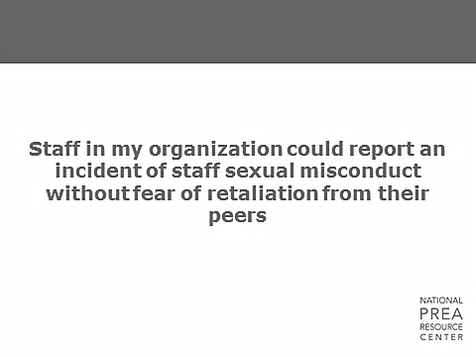  True? False? | Discuss. Why is this important? What is their impression within your agency?
1 min | If a staff member suspected another staff member of engaging in staff sexual misconduct with an offender, they would feel comfortable reporting it without proof  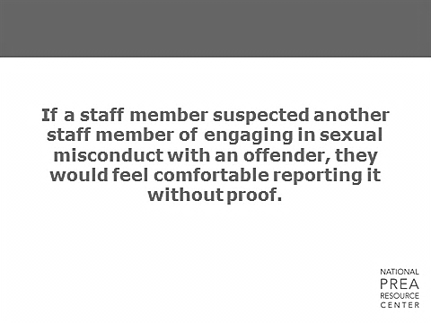  - Why is this question important?  - Why does it matter if staff would be willing to report a suspicion?  Most staff who would report probably won’t have clear proof. It’s very important for staff to be able to report a suspicion without feeling that they are betraying a colleague.  - If, as an investigator, you believe staff is not comfortable reporting suspicions, make an effort to communicate that during incident reviews and follow up.  - Administrators can take steps to increase reporting, including ensuring that policy requires the reporting of suspicions as well as incidents, providing training demonstrating what sorts of scenarios are reportable and, since we all know that staff will never feel completely comfortable reporting a suspicion, giving staff the tools to talk to another staff member in the event that they are concerned. You can also consider providing anonymous “unusual occurrence” reporting forms to staff for small things they note as unusual. | Discuss. Why is this important? What is their impression within your agency?
1 min | Offenders in my facility could report an incident of sexual abuse without fear of retaliation from other offenders or staff  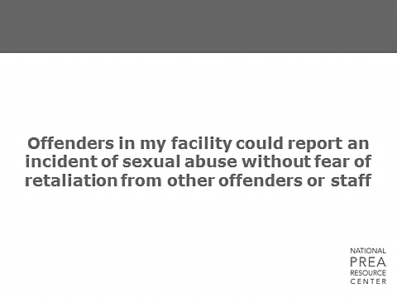  True? False? What can be done to increase offender comfort in reporting? | Discuss. Why is this important? What is their impression within your agency?
1 min | Code of Silence – Many Costs  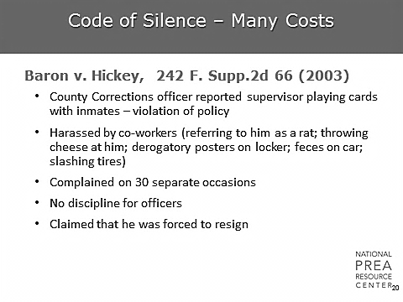  Here’s an example of a lawsuit that took place due to a very active code of silence culture in an agency. In this case, an officer who reported a policy violation by a supervisor experienced retaliation and was eventually forced to resign. | Code of Silence
1 min | Code of Silence  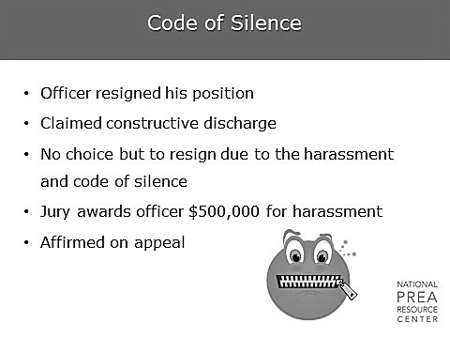  He sued and was awarded half a million dollars. | Code of Silence
1 min | What does this mean for my agency?  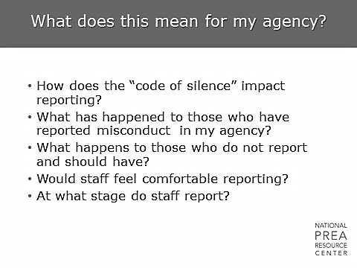  If staff are not reporting or not willing to cooperate with investigations, what happens? | What does this mean for my agency  Discuss.
1 min | In my agency, cases referred for prosecution result in indictments  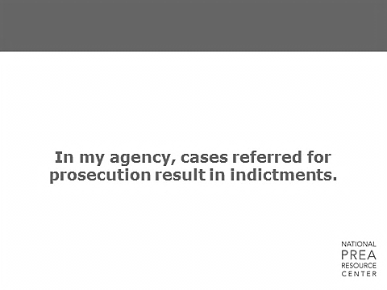  All the time? Sometimes? Never? Do you know? | Discuss. If participants don’t know, this is equally worthy of discussion. Why don’t they know? How does the answer to this question impact investigation strategies and perceptions of investigations within the agency?
1 min | Impact of Prosecutions on Agency Culture  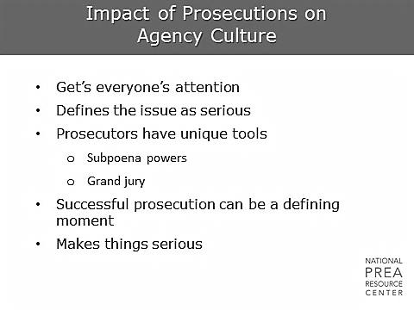  Prosecutions, or lack thereof, can have a substantial impact on the culture of an agency, including staff and offenders’ perceptions of the seriousness of sexual abuse.  - Prosecutions define the issue as serious and bring people’s attention to the problem.  - A lack of prosecutions can do the exact opposite.  - We will discuss prosecutions and how investigators can enhance the likelihood that cases will be successfully prosecuted later in the training. | Impact of Prosecutions on Agency Culture
1 min | Challenges for Leadership  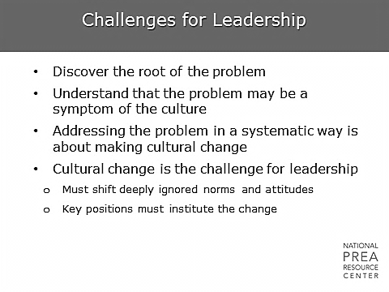  Of course, this isn’t always an easy problem to solve. Culture change is slow and requires intentional steps over a long period of time. | Challenges for Leadership
1 min | Strategies for Changing Culture  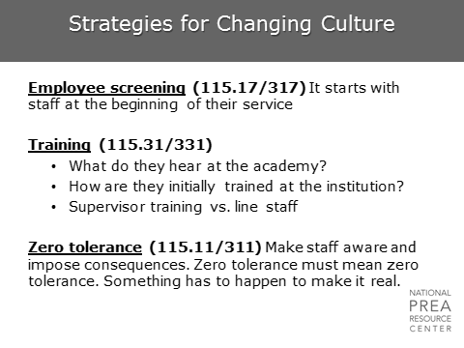  Strategies for changing culture impact an organization at all levels.  - They start with who is hired, how they are trained and, of course, agency mission statements and values. The PREA Standards support this through requiring agencies to take a zero-tolerance approach and through requiring specific training.  - Strategies must address what staff hears at the Academy and how initial facility training is sequenced with that. Consistency of training at this point is also important; trainees should not learn one thing at the Academy and then be taken under the wing by a seasoned staff at the facility and told that things are done differently on-the-ground. Supervisory training can also be adjusted to ensure appropriate oversight is provided. Finally, training can impact staff perception of zero tolerance as either a meaningless phrase or as a core value of the agency. | Strategies for Changing Culture
2 min | Strategies for Changing Culture  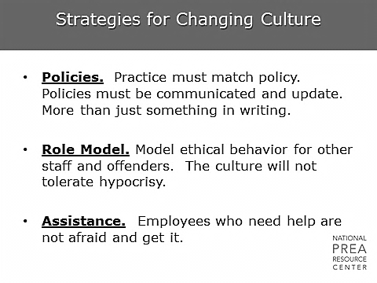  Strategies include policy writing, ensuring practice matches policy, and providing assistance to employees in need.  - What kind of assistance is provided to employees within the facilities? What if they start to have problems with boundaries? Would they feel comfortable seeking help?  - The second bullet is particularly relevant to investigators: Are you role modeling ethical behavior? Does staff trust investigators in your agency to be impartial and do your job in an ethical manner?  Role modeling also extends into the reporting area as the PREA Standards require all employees to immediately report knowledge, suspicion, or information regarding sexual abuse and harassment. If staff are not actually meeting this requirement, then investigators are not receiving the information they need to follow up. | Strategies for Changing Culture  Discuss. If yes, why? If no, why not? How can you improve?
2 min | Strategies for Changing Culture  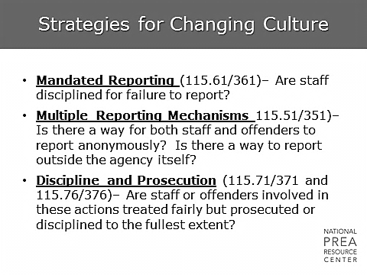  If staff aren’t disciplined for failing to report, many staff won’t feel that the benefits of reporting (which are ambiguous and far in the future) will outweigh the potential risks (which include isolation, alienation from peers, loss of job opportunities, etc.). Providing anonymous reporting mechanisms can help encourage both staff and offenders to report.  More importantly, investigations must lead to some sort of consequence for those who are found to have violated policy or broken the law. If offenders and staff don’t see appropriate discipline or prosecution, they will see little incentive in reporting. In some cases, they may also see little incentive in not perpetrating sexual abuse themselves. | Strategies for Changing Culture
1 min | Impact of Culture on Investigations  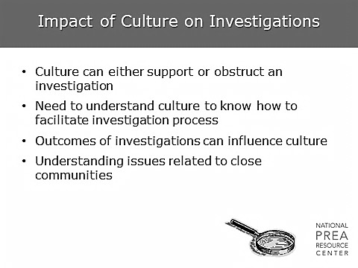  Culture has an enormous impact on investigations and their success or failure. Understanding the culture in which you are investigating can help an investigator ask the right questions to increase cooperation. | Impact of Culture on Investigations
1 min | Staff in my facility trust the investigative process  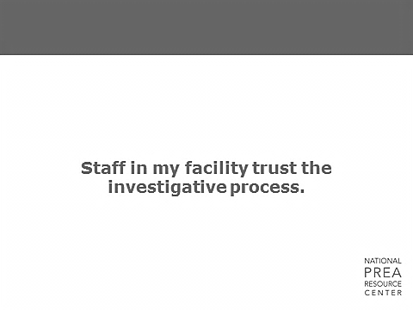  True? False? | Discuss. What does trust mean in this context? Why is this important? What is their impression within your agency?
1 min | If asked, how many staff would be able to describe what would happen to them if they were under some kind of investigation?  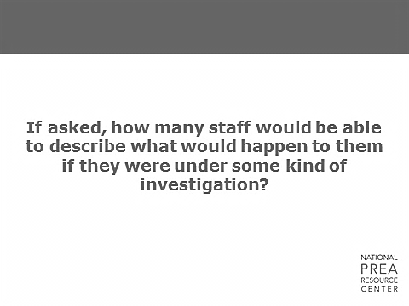  How many staff members receive pre-service training on the investigative process? Do you do a mapping exercise with them? | Discuss. Why is this important? What is their impression within your agency?
1 min | If a staff member is innocent but under investigation, how many would say they have trust in the investigative process to exonerate them?  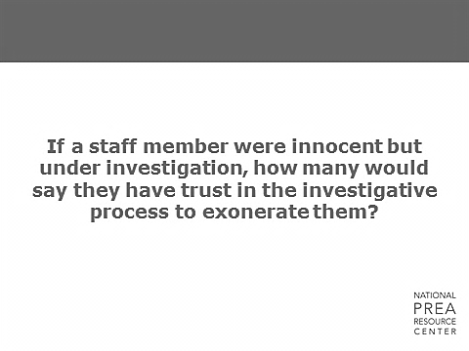  Often, staff are confident that they’ll be exonerated on the main charge, but they’re certain that the investigator will find something else (a policy violation, etc.) to get them one way or another. Is that the case here? | Discuss. Why is this important? What is their impression within your agency?
1 min | Staff members under investigation in my facility believe they are adequately kept up-to-date as the investigation proceeds  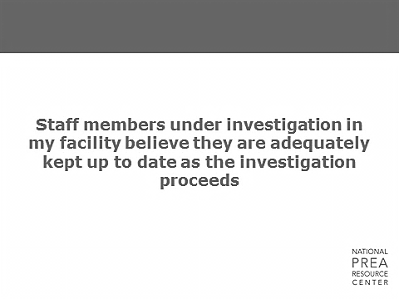  True? False?  Is staff kept in the dark or is there regular communication, if only to say that it’s still ongoing? | Discuss. Is this a policy issue or a practice issue? How can investigators impact this?
1 min | In my facility there is a strong rumor mill which is where people find out about ongoing investigations  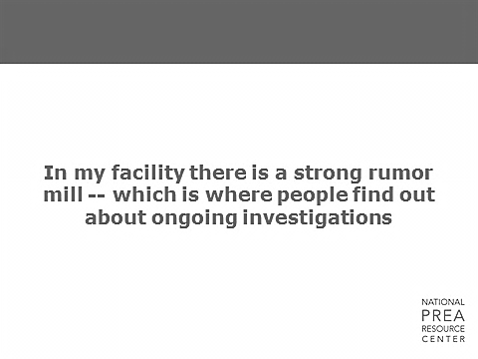  True? False? | Discuss. Why is this important? What is their impression within your agency?
1 min | Staff in my agency believe investigations are handled in a timely manner  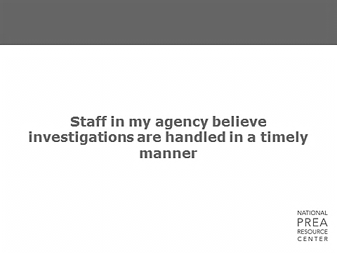  True? False? | Discuss. What does timely mean? How can investigators impact this?
1 min | Staff under investigation receive a written notice of results when an investigation is concluded  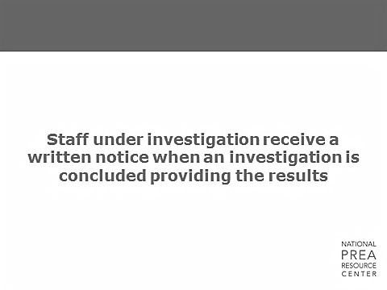  True? False? | Discuss. Why is this important? What is their impression within your agency?  Insert questions specific to agency policy, if appropriate.
1 min | Offenders in my agency trust the investigative process  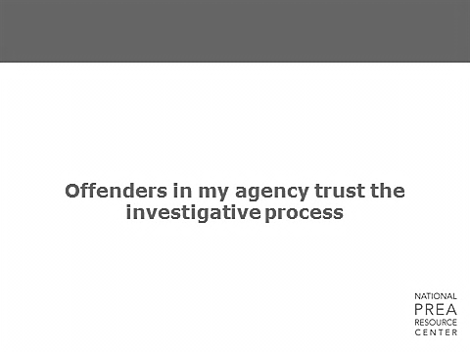  True? False? | Discuss. How does this impact reporting? How can the agency impact this? How can investigators impact this?
1 min | Investigative Process  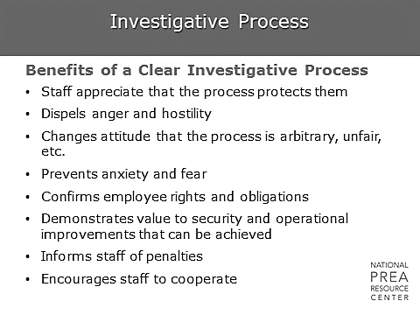  A clear investigative process can be extremely beneficial to the cooperation levels received by investigators and the eventual success of the investigation. | Investigative Process
1 min | Strategies for Changing Culture – Demystifying the Investigative Process  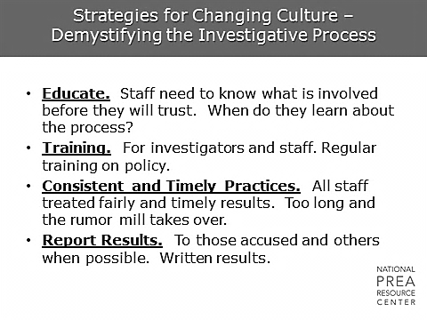  Consistency in investigations with regards to the process, the timing, and the information staff receive can enhance staff and offenders’ trust in the process and make an investigator’s job a lot easier. | Strategies for Changing Culture
10 min | Activity  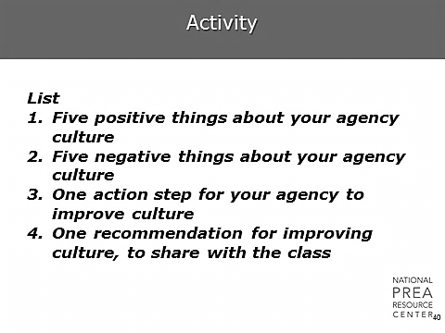  List:  - Five positive things about your agency culture  - Five negative things about your agency culture  - One action step for your agency to improve culture  - One recommendation for improving culture, to share with the class | Activity
1 min | A Word About Changing Culture  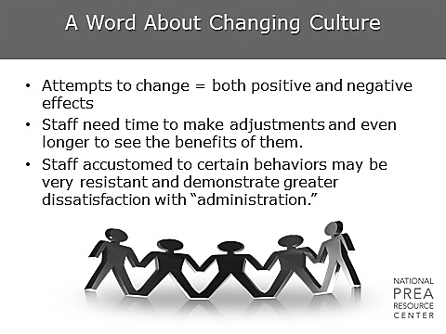  - Those who have been involved with change agree that developing a plan and establishing a vision with input from the management team and line staff begins the process of changing culture. Staff and managers do not work together effectively when they are unclear about the agency’s vision, so the first step is always clarifying the vision from the top.  - Lessons learned in the field show that, after the direction has been established, leadership needs to listen and then talk to staff, inmates/residents, volunteers, contractors, the unions, and the community. Everyone needs to understand the plan and how the institution/organization hopes to achieve its goals. Participation from staff is key, as is finding ways to get staff invested in the mission. | A Word About Changing Culture
1 min | Questions?

